Camps – uncertain location / details.

1. Camps where I am looking for confirmation - or were hostels.

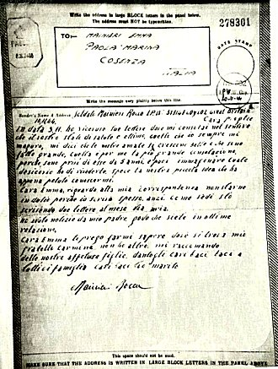 | Camp 44 Haswell House Camp, Somerset. Name appears in WO 32/10737 – with a sub-camp at West Lambock, (West Lambrook list with C44) Martock, Somerset. (C44 was Goathurst Somerset – Haswell does not appear in lists I have seen.)  Camp 176 West Chillington Camp, Pulborough, Sussex. Italian pows 1944  Camp 221 ? National Archive WO 166/16296 – 221 Prisoner of War Camp at Lavington. Camp moved from Lavington to Bustard, July 1944. Dated July 1944.  Camp 223 ? National Archives WO 166/16297 – 1944 223 Prisoner of War Camp at Aldershot, Hampshire. Moved to Haltwhistle, Northumberland; from there to Cumnock; from there to South Woodford. Dated February to April 1944.  < Airgraph from Italian Pow Company 602. Camp not listed.  Camp 701 – RAF Station Hednesford, Staffordshire _ 6 hostels. 1944 /45 Italian Labour Battalion

Camp ??? - SOUTHEASE POW CAMP
The P.O.W camp was at Rodmell ,Passed the Pub on the R.H. side on top of the bank just before you go down the dip and up to Southease .
platforms and concrete bases of 16 Nissan huts, used as a PoW camp
IWM pow at Southease - Behrens, Hans https://www.iwm.org.uk/collections/item/object/80013924

Camp ??? - Newcastle, Nuns Moor Park, Prisoner of War (POW) Camp (HER 5891) - Grid Reference: NZ23406510
A World War Two prisoner of war camp used to occupy the eastern half of Nuns Moor Park, situated on the green to the north of Studley Terrace. It can be seen on aerial photographs from 1944, and was used to house Italian prisoners who were deemed to require a very low level of security. Prisoners were let out to do menial work in the town, such as road sweeping. The camp appears to have been defended by trenches to the west, which can be clearly seen on 1947 aerial photographs. These were constructed in a zigzag pattern, which was the standard construction method throughout both World Wars. The camp was demolished in 1959. To the south of the camp there are a series of rectangular earthworks, each 16 x 10m, and up to 30cm deep. These could be another type of ditch, or could possibly be a platform for Nissen huts or similar temporary buildings. They can be seen under construction in 1946 aerial photos (RCHME 1995).
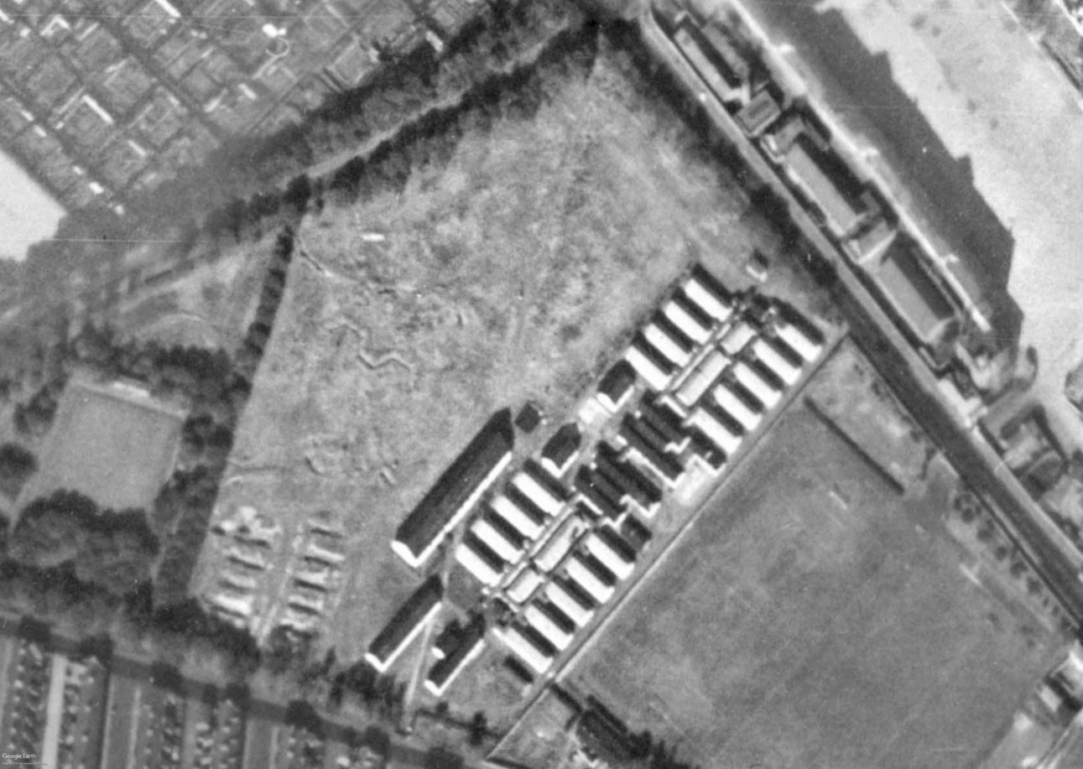
HER - Situated on the green to the north of Studley Terrace, occupying the eastern half of Nunsmoor Park. It consisted of a number of parallel accomodation blocks and other large buildings. Can be seen on 1947 aerial photographs. The occupants were Italian prisoners of war. The camp had a low level of security. Prisoners were let out to do work around the town such as road sweeping and postal delivery. The camp seems to have been defended by several trenches to the west. These are still visible as low earthwork ditches or parchmarks, and are visible on 1947 aerial photographs. All exhibit the same configuration of short angled lengths in a zig-zag (similar patterns can be seen in practice trenches on the Salisbury Plain training area and elsewhere). The camp was demolished in 1959.

In Nuns Moor Park, immediately to the north of Studley Terrace, a Prisoner of War camp was located. The site occupied the eastern half of the park and consisted of a number of parallel accomodation blocks and other large buildings. The camp housed Italian prisoners of war who were let out to do work around the town such as road sweeping and postal delivery.
The site seems to have been defended by several trenches immediately to the west which are still visible to this day in the form of shallow depressions.

A 1947 aerial image showing the POW camp at Nuns Moor Park. The defensive trench system can be seen to the left.
https://northeastatwar.co.uk/2019/02/02/nuns-moor-pow-camp/

Camp ??? - Sedbury Camp is unusual because it is known to have been a military or prisoner camp during the First World War. Photographed in 1945, it was confirmed as a POW camp based on the morphology of the site – it comprised 30 huts within a gated perimeter fence, guard towers and a recreation ground. Although Sedbury was not listed amongst the known camps, its status as a prison camp has been confirmed by a number of local amateur sources including members of the Dean Archaeology Group.
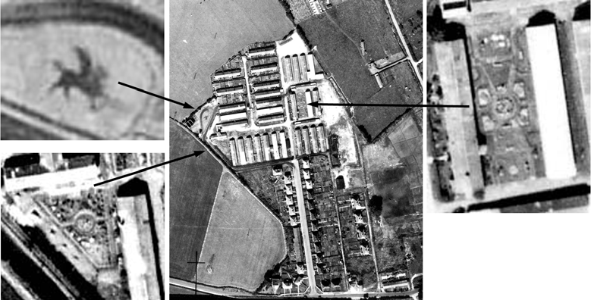
The POW camp at Sedbury with its ornamental beds and parterred gardens amongst the accommodation huts.
Extracts from RAF 106G/UK/2020 26-JUL-1945
On closer inspection this site was found to have several well established gardens, two of which were parterred (Figure 61). The most unusual part of the site was the ornamental garden or bed in the shape of a gryphon or a winged horse, possibly a regimental cap badge of one of the groups of prisoners. The widely spaced huts with interspersed cultivation are believed to have been the Officers' huts.
Sedbury camp continued in use as post war housing for ex-servicemen and their families. Some huts were demolished and gardens were laid out between the blocks. Many of the huts on the eastern side of the spine road were converted into bungalows (rebuilt in stone or brick or re-clad with brick over the original timber frame), some of which are still occupied today. The western half of the site is now used as a light industrial estate (A Webb, pers comm).
FOREST OF DEAN NMP Fiona Small and Cathy Stoertz (Eds), Sharon Bishop, Edward Carpenter and Helen Winton - English Heritage 2006

Camp ??? Another POW camp was identified on aerial photographs at Naas House, Lydney (Figure 62). When the site was photographed in 1944 the accommodation was in huts supplemented with tents. The camp was surrounded by a fence with guard towers and a gate to the west.
The presence of tents, and the unusual lay-out of the huts at Naas House, may be evidence of a massive increase in the prisoner population later in the war. After D-Day in 1944, additional tented encampments were needed to accommodate the vast number of new prisoners arriving from France. By 1945–6, Axis prisoners who had been held in Canada and the USA also began to be returned to Europe. (In the early stages of the war many prisoners had been relocated to North America, for fear that they might provide a ready-made enemy army in the event of an invasion.) Where possible, tents were replaced with huts, but many prisoners remained under canvas for a considerable length of time.
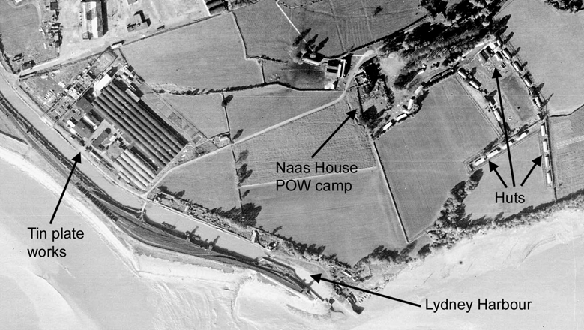
Naas House POW camp and adjacent tin plate works to the south of Lydney. Extract from RAF 106G/LA 121 3013 09-FEB-1945
© English Heritage (NMR) RAF Photography
The Naas House Camp has an unusual plan – the huts appear in lines around the edges of two fields, rather than in blocks and, particularly in the second field, the perimeter fence forms an awkwardly-shaped enclosure. The arrangement of the huts is more
typical of an army camp or supply depot, with accommodation and storage buildings placed around the edges of fields to make them less obvious from the air. It is possible that this site was originally intended for storage or for housing troops or factory workers, and only became a POW camp in the latter stages of the war.
It was common practice for low risk prisoners to be employed and billeted out on farms, but those at Lydney are believed to have worked at the tin plate works near to the prison camp, formerly Lower Forge Lydney, originally called Pill Forge. A concrete path was seen to link the camp and factory.
FOREST OF DEAN NMP Fiona Small and Cathy Stoertz (Eds), Sharon Bishop, Edward Carpenter and Helen Winton - English Heritage 2006

2. POW Camps listed by Harrington Museum, Northamptonshire.

The full list includes military premises within 30 miles of Harrington. I think some of the entries in the list refer to listed camps, but under a different name - many entries are satellite camps or hostels.

Village/ Town | Name of Premises | Location / Address | Distance to Museum | Use
Daventry |  | SP 561 635  Northamptonshire | 25.9 km | The accommodation huts formerly used by the anti aircraft battery was used by German prisoners of war. They assisted in clearing snow from roads during the severe winter of 1947.  The site then became part of the Timken ball bearing factory post war.
Daventry | Braunston Road | SP 568 628 approx Northamptonshire | 25.7 km | PRISONER OF WAR CAMP & LAND ARMY HOSTEL  Demolished shortly after WW2 and Council houses were built on the site
Denford parish |  | TL 008 757  Northamptonshire | 24.2 km | Between Briggs Lodge and Denford village are the remains of a wartime German POW camp. The men worked on local farms. Briggs Lodge Farm is east of Denford village at TL008757. Location of the camp remains undetermined  Additional information from Martin J Richards – Systonimages:  On enquiring at the farm I was told by the lady there that the PoW Camp was located further down the road at a small holding that was now called “Camp Farm” because of its former usage as a PoW Subcamp.  The location of this site has thus been up-dated From: TL 008 757 To: SP 9989 7600
Fineshade | Fineshade Abbey | SP 972 977  Northamptonshire | 27.7 km | Demolished in 1956. It had been damaged during use as a POW camp during WWII. Only the stable block remains.
Lubenham |  | Leicestershire |  | ITALIAN PRISONER OF WAR CAMP
Sulby |  | Northamptonshire |  | PRISONER OF WAR CAMP  Also used as a displaced persons camp after WW2

3. Scottish Camps
Camp Number - Name - Location | Notes
Balado Bridge | Known that 113 Polish pows were moved from Camp 905 on 15 December to Bolado Camp, Kinross. Balado Bridge was a RAF airfield with various accommodation sites. The airfield closed in June 1944 and the site acquired by the War Office. Two large accommodations sites were:  Turfhills (NO 1079 0286) to the southeast, a substantial camp, larger than would have been needed to service RAF Balado, and assumed to have been used to accommodate other units, and Polish troops, both during and after the war. Canmore notes that it may have housed Polish troops before and after the war – I wonder if this might have been Polish Pows?  Braidmyre Wood camp (NO 0823 0362) comprised some thirty assorted hut types.
Brucklay, Aberdeenshire. NJ913501 | Hut bases remain.
Capeldrae, Westfield, Ballingry, Fife. NT19639777 | Possibly former Bevin Boy camp.
Culreoch Camp, Stranraer. NX06915829 | Housed Italians postwar. Former AA battery astride A71. RCAHMS entry, Culreoch AA battery
Duddingston House, Edinburgh. NT28607270 | Destroyed.
Hampden Park Football Stadium, Glasgow. | Scottish Command holding cage. Extant.
Hayton Camp, Hayton Road, Aberdeen. NJ93250900 | Destroyed. RCAHMS entry, Hayton Road
Kinlochleven, Argyll & Bute. NN20656070 | Destroyed.
Kirkton camp, former RAF station, possibly SLG. | The Northern Times, Mr D Stewart, 7 Moray Drive, Balloch, Inverness. April 10, 2008.  Sir – Further to your previous correspondence regarding the RAF camp at Kirkton Farm, after the RAF left Kirkton the camp lay empty for a short period and then became a prisoner of war camp for Italian POWs.  After that, German POWs occupied the camp and many of them worked on farms in the area. Several of the German POWs remained in the area after the war, in fact the entire Golspie football team half back line were former POWs, namely Arnold, Bruno and Gustav.  Arnold and Bruno eventually returned home but Gustav married a Golspie lass, Chrissie Macdonald. Sadly Chrissie and Gustav are deceased but their children live in Golspie.
Leucahtsbeath Cottages, Cowdenbeath. NT16379277 | Possibly former Bevin Boy camp. Destroyed.
Maidens/Kirkoswald camp. NS216078 | Now Redgates caravan park, Kirkoswald Rd, Maidens.
Methven Airfield/Loanleven. Perth & Kinross. NO055255 | Former wartime satellite airfield. Some buildings remain.
Peterculter Camp, Coronation Road, Aberdeen. | Destroyed. No trace found.

4. Welsh Camps
Camp ??? Peniarth

Location: SH 6118 0601.  Before the camp:  Pow Camp:  Coflein – “World War 2 camp for prisoners of war, consisting of several huts to the North of Peniarth house (nprn:- 28633) and recorded by RCAHMW aerial reconnaissance 2nd June, 2009.”  After the camp:  Further Information: | 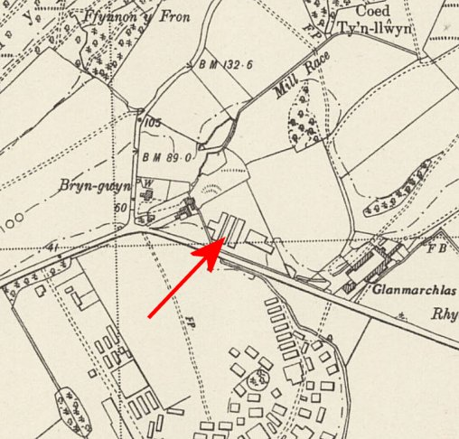
 | Ordnance Survey 1953

Camp ??? Treglog, Carmarthenshire

Location: SN 5954 3502. Treglog shown in NE of map.  There is a listing of a UK / US military base at this site (PRN – 30261). Royal Marines were followed by US troops up to D-day. Nissen huts.  Before the camp:  Pow Camp:  Listed by Coflein as a pow camp – no details given  After the camp:  Further Information: | 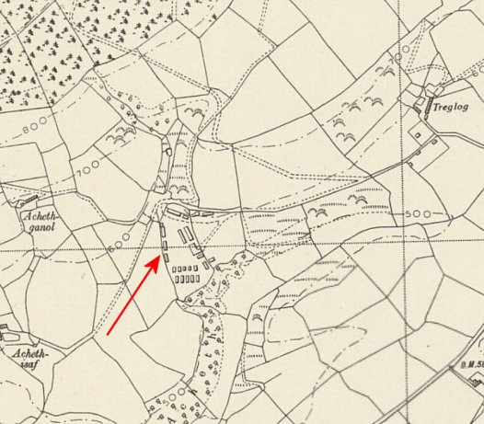
 | Ordnance Survey 1953

Camp ??? Y Sgwar (Square and Compass), Mathry, Pembrokeshire

Location: SM 8517 3131. Square and Compass is the name of the Public House shown on the map.  Before the camp:  Pow Camp: HER DESCRIPTION – “A hostel and camp for the Women's Land Army. Consisting of a combined ablution and accommodation block and a further accommodation block. Three curved asbestos garage/implement stores, a septic tank and filtration bed. It later became a Prisoner of War camp for mostly Italians captured in North Africa. Recorded by RJC Thomas as site no 406. A Pyper 2017”  After the camp:  Further Information:  Aerial photograph - RAF 04.05.46. Sortie No. 106G-UK | 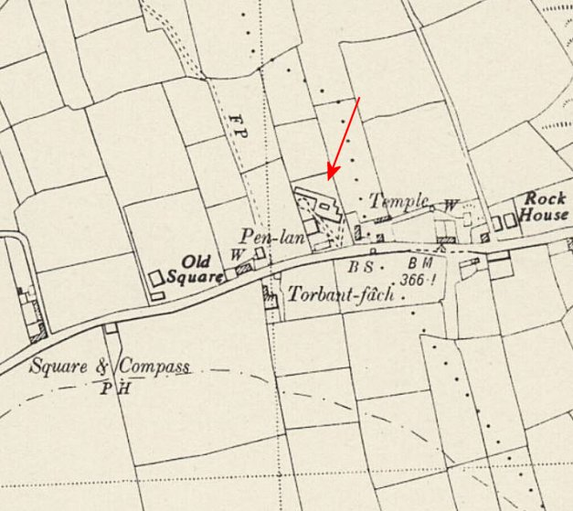
 | Ordnance Survey 1964

