Camp 784 Thorndon Hall, Brentwood, Essex (+ Shenfield Hall).

ICRC – Labour Camp. 784. Thorndon Hall, c/o GPO Brentwood, Essex.

Location: NGR for the house TQ 6165 9176  Before the camp: Large country house and park. Leased and later sold to Thorndon Golf Club. Part of the parkland was used as Marshalling area S5 prior to D-day.  Pow Camp:  Probably a short-lived camp at Thorndon Hall before relocating to Shenfield Hall about 3 miles north TQ 606 952.  April 1945 – Camp list; “Italian Artizan Working Company, 784, Shenfield Hall, C/O GPO Brentwood, Essex, E(ast)” With a war establishment V/1373/1.  After the camp: Thorndon 1976 converted to apartments and cottages.  Further Information: | 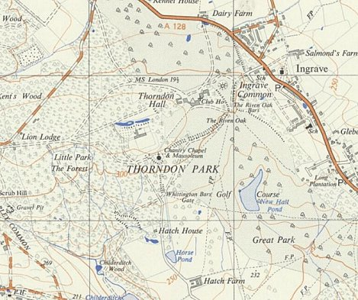
 | Ordnance Survey 1955

