Camp 783 Dinorben Court, Dinorben Avenue, Fleet, Aldershot

ICRC – Labour Camp. 783. Dinorben Court, Dinorben Avenue, Fleet, Hants.

Location: NGR for the House SU 8040 5310  Before the camp: Large house and grounds. Parts of the estate being sold off from 1935 for housing. Grounds and large houses were used to accommodate troops.  Pow Camp: Italian pows  Memory of the camp, sent without a name – “He said that as a child in the war he and his friends used to go to Dinorben House when it was used to house Italian prisoners of war. There was one guard on the main gates to the house but the children were able to wander freely and speak to the Italians. Some of them gave metal cigarette lighters and asked the children to sell them for a shilling. They did and had a spaghetti meal as a reward.”  After the camp: Used as emergency, temporary housing. The house was de-requisitioned in 1956. Soon after the house was demolished. 2020 residential area and school  Further Information: | 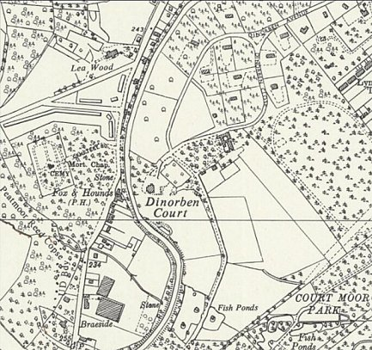
 | Ordnance Survey 1961

