Camp 782 Huntercombe, Henley-on-Thames, Oxfordshire

ICRC – Labour Camp. 782. Huntercombe, Henley-on-Thames, Oxon.

Location: Several sites would be possible including the Huntercombe Place Prison / Borstal (SU 679 881).  Before the camp:  Pow Camp:  Early 1945 – “Italian Artizan Works Companies; 782, North Camp, Nettlebed, Henley-on-Thames, Oxon.” Likely to be the same camp – Nettlebed / Huntercombe are 2 miles apart.  Postal item seen for February 1946.  After the camp:  Further Information:  Note - Camp 020R was also based at Huntercombe. This was an interrogation centre / internment camp. | 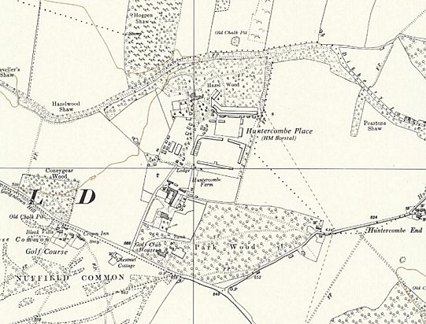
 | Ordnance Survey 1960

