Camp 1010 Weedon Camp, Weedon Bec, Northamptonshire

1947 Camp List
1010(G.W.Coy) | E | The Camp, Weedon, Northants | Weedon 131 | 9 | V/1270/4

Prisoner of War Camps (1939 – 1948) - Project report by Roger J.C. Thomas - English Heritage 2003
OS NGR | Sheet | No. | Name & Location | County | Cond’n | Type 1945 | Comments
SP 6259 5954 | 152 | 1010 | Weedon Camp, Weedon Beck | Northamptonshire | 5 | German Working Camp | Precise location not identified. NGR for centre of Ordnance Depot.

Location: Weedon Bec is usually just called Weedon.  Before the camp: Large barracks and military storage depot.  Pow Camp:  June 1947 – 2 Pows detained at the camp as suspected war criminals wanted by the French;  Sgt Otto Bartels for ‘Brutality’. (C.R. file 149357).  Agent Arnold Schulz, merely described as ‘Suspect.’ (C.R. file 262616). FO939/454.  After the camp:  Further Information:  London Metropolitan Archives: City of London – LMA/4288/D/04/006 – The Dietrich Bonhoeffer Kirche (German Church, Sydenham) worked with many pow camps. There are various camp related documents in the collection. This item is a copy of Camp 1010’s Pow newspaper (No 4) written in German, 1946. | 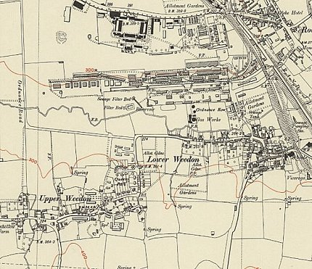
 | Ordnance Survey 1952

