Camp 1006 Willems & Beaumont Barracks, Aldershot, Hampshire (cf Camp 1019).

Prisoner of War Camps (1939 – 1948) - Project report by Roger J.C. Thomas - English Heritage 2003
OS NGR | Sheet | No. | Name & Location | County | Cond’n | Type 1945 | Comments
SU 8571 5098 | 186 | 1006 | Willems Barracks (West Cavalry Barracks),  Aldershot | Hampshire | 5 |  | Precise location not identified. NGR for  centre of Willems Avenue. Tesco store and housing.

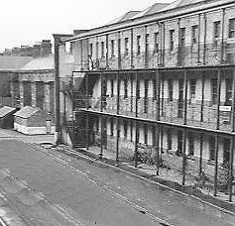  Location: West Cavalry Barracks shown off Wellington Avenue.  Nearby Beaumont Barracks was also used as a pow Camp and used the numbers 1006 and then 1019.  Before the camp: Cavalry and various army unit barracks  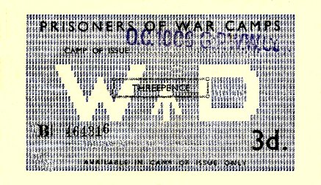  Pow Camp:  < the barrack buildings  Pow money vouchers were issued in various values and could only be used in the camp of issue.  November 1946 - Camp magazine for Beaumont Barracks Camp 1006 – Der Wille : G.P.W.W.Coy. Beaumont-Barracks Camp 1006 - The Wiener Holocaust Library  There is an account of a football match where players on 1 team were made up of pows from Camps 614, 671, 675, 676, 1006, 1016, 1019 – all in Hampshire, except for 1016 in Surrey.  After the camp: 2020 motel.  Further Information: | 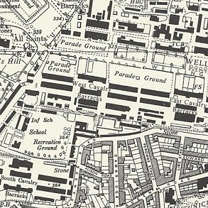
 | Ordnance Survey 1961

