Camp 1003 Capel House Camp, Bullsmoor Lane, Enfield, Middlesex

1947 Camp List
1003(G.W.Coy) | L.D. | Capel House Camp, Bullsmoor Lane, Middlesex. Postal Address:- Bullsmoor Lane Camp, Enfield, Middlesex | Waltham Cross 2696 & 4083 | 17 | V/1270/4

Prisoner of War Camps (1939 – 1948) - Project report by Roger J.C. Thomas - English Heritage 2003
OS NGR | Sheet | No. | Name & Location | County | Cond’n | Type 1945 | Comments
TQ 3446 9962 | 166 | 1003 | Capel House Camp, Bullsmoor Lane, Enfield | Middlesex | 5 | German  Working Camp | Precise location not identified. NGR  given for parkland near Capel House.

Location: Memory: “I lived in Bullsmoor Gardens and the prisoners of war camp was across the road from me. As children we were always over there and they made us toys. If I can remember we had our VE Day with them. We also had Polish in that camp after the Germans went. Before they were there the ack ack guns were there and the noise from them” Facebook entry. https://www.facebook.com/groups/4250072884/posts/10159149311012885/  Before the camp:  Pow Camp:  10 December 1946 - As part of the re-education programme administered by the Control Office for Germany and Austria (COGA), Paul Bondy, a German-speaking refugee gave a lecture at the camp, which he called ‘Waltham Cross’.  Christmas 1946 - Camp magazine; Lager-Kurier : P.O.W. Camp 1003 - The Wiener Holocaust Library  Camp leader: Kurt Boehmer.  February 1947 – a note in a report for Carpenters Lane Camp 30 noted that the two padres from this camp regularly visited their hostels. Protestant padre – Meyer (A); RC padre – Braun.  End April 1947 - Note in report for Setley Camp 65 that Camp 1003 had closed and its protestant padre, Adolf Woertz, had been transferred there.  After the camp:  Further Information: | 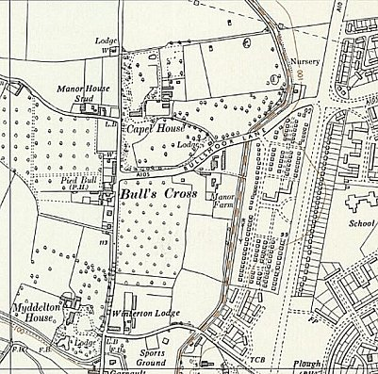
 | Ordnance Survey 1961

