Camp 702 Jurby, Isle of Man

Prisoner of War Camps (1939 – 1948) - Project report by Roger J.C. Thomas - English Heritage 2003
OS NGR | Sheet | No. | Name & Location | County | Cond’n | Type 1945 | Comments
 |  | 702 | Jurby, Isle of Man | Isle of Man |  |  | Isle of Man

Location:  Before the camp: RAF Aerodrome.  Pow Camp:  In huts at RAF Jurby.  After the camp: Industrial estate.  Further Information: | 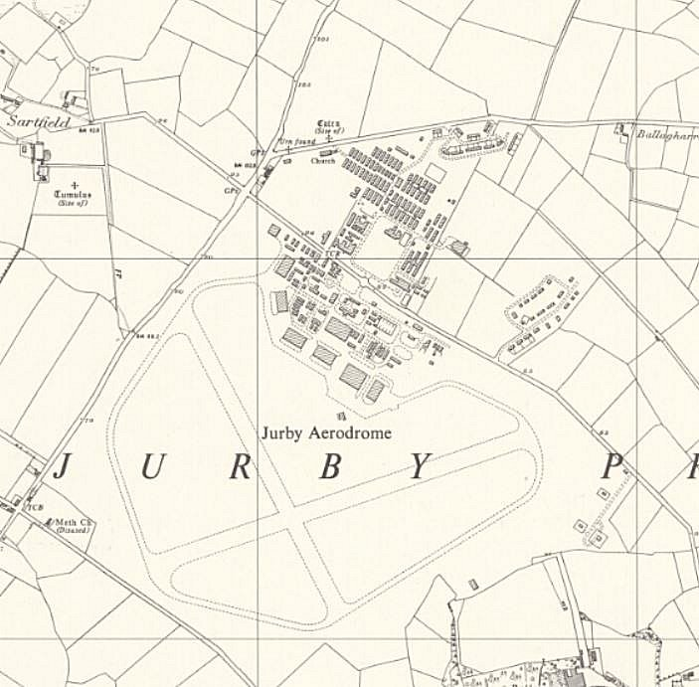
 | Ordnance Survey 1957

