Camp 701 Sheffield Camp, Sheffield, Yorkshire

ICRC – Labour Camp. 701. Address non communiqué.

I am not sure if this camp is linked to the large Lodge Moor camp. Both sites appeared in listings at the same time.

Location:

Before the camp:

Pow Camp: Italian pows

The Forces Postal History Society have recorded mail from July 1944 to July 1946 and comment; “There may have been satellite camps around Sheffield using 701 with suffixes A/B/C/D9/E/F” ‘A2’ also recorded.
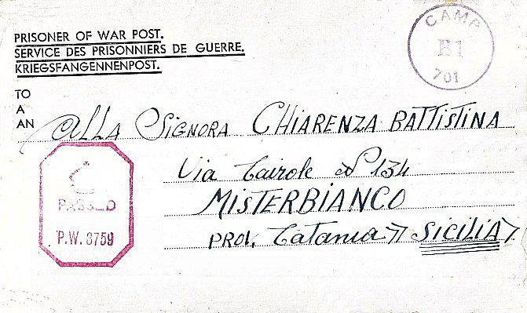
< Letter-sheet date April 1945 – note ‘B1’ inside the camp’s cachet.

After the camp:

Further Information:
Ordnance Survey

