Camp 695 Borgard Barracks, Shrivenham, Wiltshire (aka Horgard)

1947 Camp List
695(G.W.Coy) | S | Borgard Barracks, Shrivenham, Nr.Swindon, Wilts | Swindon Trunks 17 Ext.1 | 52(W.O.) | V/1270/4

Prisoner of War Camps (1939 – 1948) - Project report by Roger J.C. Thomas - English Heritage 2003
OS NGR | Sheet | No. | Name & Location | County | Cond’n | Type 1945 | Comments
SU 2546 9067 | 174 | 695 | Horgard Barracks, Shrivenham | Oxfordshire | 4 | German Working Camp | Camp comprising some 120 bell tents within an irregular fenced compound guarded by watchtowers. Housing and vehicle park.

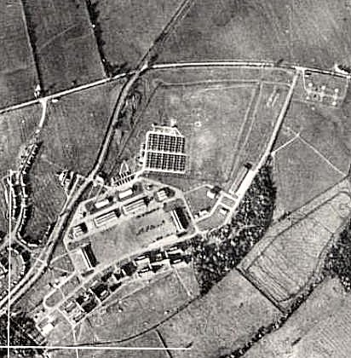  Borgard / Horgard? The correct name for the camp was Borgard – though many sources list Horgard. It was named after Albert Borgard a Colonel of the Royal Artillery in 1716.  Location: On the edge of the village of Watchfield. 1947 aerial photo - View map: Ordnance Survey, OS Air Photo, 6 inch to the mile (1:10,560), Sheet 41/29 S.E. - Ordnance Survey Air Photo Mosaics, 1944-1950  Before the camp:  Pow Camp: “There was also a Prisoner of War Camp for captured Germans which was the traditional square shape with the four guard towers on each corner. Its location was where the old guard room stands just west of the present day entrance roundabout. (Grid ref SU 2525 9045). Mrs Maureen Coyle remembers that many of the Prisoners were employed keeping the local roads clear. She also recalls that during one Christmas, families living in the army quarters were permitted to entertain two prisoners and that some of them made beautiful wooden toys for the children.”  http://publications.shrivenhamheritagesociety.co.uk/29-the-military-college.pdf  14 April 1946 – Camp opened for German pows. They had been held in camps in the USA. Most had very low | 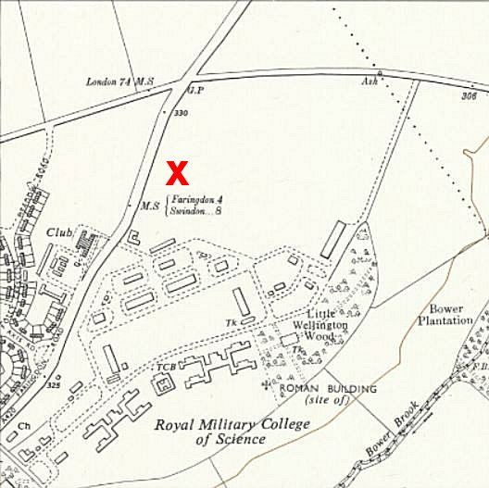
 | Ordnance Survey 1961
morale as they had been misinformed in the US they were being repatriated. Instead, they found themselves in working camps in the UK.

Oversight and development of re-education activities and English teaching for German pows was carried out by PID (Political Intelligence Department of the Foreign Office) / COGA (Control Office for Germany and Austria – UK). Visits and reports were made. The standard of the reports varied greatly. The visitors took little interest, if any, in activities other than re-education. They rarely mentioned welfare, sports, games, pastimes, crafts, etc of the pows. If there were still Italian pows in hostels, they were usually ignored by PID.

18-19 July 1946 – General survey and seek candidates for the special pow training course at Wilton Park. Strength; 0 officers, 797 Other Ranks.

Commandant: Major L A L Clark Camp leader: O/Fhnr Stolz (est A)
Interpreter: None Deputy C/L: Ofw Mahncke (est B)
German M.O.: None

The Commandant showed some interest in re-education.

The Camp Leader was aged 25, “but is intelligent and commands the respect of his fellows.”

Accommodation was mainly tented. Most of the pows were employed in the Military College of Science.

Full political screening had only taken place with 7 pows. Estimated screening (‘ballot’ screen); A 38 / B 581 / C 171. (A Non-Nazi > C Nazi).

There were 2 candidates for the special training course.

Morale was recorded as low, due to the promise of repatriation given in the US, bad news from home, irregular mail, menial work cleaning or maintenance, and accommodation in tents.

35% of the pows were ‘youth’ (under-25). They were not regarded as a problem.

Little had been done to develop re-education activities, mainly due to apathy from the British and Germans. There were some pows willing to assist. One pow ‘Műller,’ was regarded as a very suitable leader; middle aged, studied law, became a journalist and in 1933 joined the Foreign Legion. On his return to Germany had had been put into a concentration camp before being enlisted.

The standard list of re-education activities was given:

Wochenpost and Ausblick – None. 200/120 copies respectively were requested.

Newspapers – 15 British papers. 2 or 3 German papers sent weekly by PID.

Library – Just 109 books.

Lectures – 3 lecturers had visited since opening.

Discussion group – hoped to start.

Films – It was hoped the camp would receive films from the YMCA.

Wireless – 1 set and 2 loudspeakers.

Camp magazine – hoped to start. Paper and stencils needed.

English instruction – separate appendix.

Other camp activities –

Religion – 40-45 Protestants and 120-130 RC were attending local services.

Education – Classes for French. It was hoped to start more classes.

Entertainment – There was a good stage, the first performance had been given. Make-up and wigs requested. It was hoped to start an orchestra if they could obtain instruments.

19 and 21 March 1947 – Re-education report. Strength; 2 officers (the M.O.’s), 498 O.R.

It had been 8 months since the last report – and there were clearly problems of leadership; British and German.

Commandant: Major Hunter Camp leader: S/Fw Arthur Meyer (B)
Acting C.O.: Capt Waters Deputy C/L: O/Fw Werner Wessel (B+)
Interpreter: Sgt Smartley German M.O.: S/Arzt Jurgen Pfeil (B) & S/Arzt Walter Harke (B)

The Commandant was on leave and expected to retire. He had “forbidden Ps/W to talk politics” which did not encourage any democratic ideals.

The acting CO was regarded as excellent, however the rest of the British staff had a poor attitude with, “a tendency to penalize small offences heavily.”

Interpreter Smartley was recorded as “an unimpressive individual with no personality and quite incapable of carrying out any re-educative work.”

The camp leader had been a professional soldier 1927 to 1939, and then recalled in 1942. The visitor found him to be unsuitable for the job; “a very stolid, simple man with no political understanding and is not well informed as to what is going on in the camp. He seems afraid of his men.” In this report it was stated he would be replaced by the deputy – however the Commandant then took no action and he was still in place for the next report in June.

One of the M.O.s, Walter Harke, was due to be repatriated on medical grounds.

Political screening: A 3 / B 497 / C 0. 6 pows were appealing against their grades; the better the grade, the sooner repatriated, in theory. 33 appeals had been heard, 27 allowed, 6 rejected. 160 pows repatriated to date.

Morale was “not very good,” but had slightly improved with the start of repatriations. Considering the attitude of the Commandant, not surprisingly, there was no political life or improvements in the camp, and even entertainment facilities were poor. The camp remained partially tented throughout the winter – these had been recently replaced by huts.

25% of the pows were youth. These were now regarded as a problem as they had received no political education at all.

A new re-education officer was appointed during this visit. There had been slight improvements since the last report.

Wochenpost and Ausblick – Some copies had arrived, separate appendix.

Newspapers – “Adequate.” Some articles displayed in the canteen.

Library – 500 books.

Lectures – None since last autumn, extremely poor in comparison to other camps. The report does not state why, I wonder if the Commandant’s order forbidding talk on politics was the cause.

Discussion group –None, again hoped to start.

Films – “Adequate.”

Wireless – Hoped to instal extension speakers.

Camp magazine – Monthly. Paper and stencils needed.

Press reviews – none.

English instruction – separate appendix.

Information room – None.

Other camp activities –

Religion – “Facilities adequate. Not a great deal of interest.”

Education – None other than English classes.

Entertainments – None. Theatre group disbanded due to repatriations.

May 1947 – Camp Magazine No.4; Huttenzeitung : P.O.W. Camp 695 - Shrivenham - The Wiener Holocaust Library

4/5 June 1947 – Re-education report. Strength; 1 officer, 505 OR at HQ and 1 hostel.

413 in HQ / 68 at Thatcham Hostel / 18 detached to Didcot Camp 652 / 7 detached at Stratton Factory.

Commandant: Major R J Bryant Camp leader: S/Fw Arthur Meyer (B)
Interpreter: Sgt Wiener Deputy C/L: Uffz Karl Jaeger (B)
German M.O.: O/Arzt Ernst Enhuber

The new Commandant supported the aims of re-education. As a result, the attitude of the British staff was recorded as having improved.

The recently appointed Interpreter was a Dane. He did not participate in re-education activities.

The unsuitable Camp leader was still in place, but as the camp was due to close, no action was taken.

Deputy Jaeger, aged 25, a clerk, Protestant; “Intelligent and alert; quite non-political but has a decent outlook.”

The MO had previously been based at Camp 674, aged 32. He clearly was not liked by the visitor; “a very self-centred individual and rather sly. Suave, pleasant mannered and an opportunist.”

Political screening; A 0 / B 505 / C+ 1. 1 appeal pending, no information about previous appeals. 318 pows repatriated to date.

Morale had improved with the arrival of the new Commandant. Negative aspects were slow repatriation, slow mail, poor quality cigarettes – one consignment was full of maggots, and uncertainty about which camp they would be posted to. Some pows were carrying out local garden and handy work in order to obtain cigarettes.

50% of the camp were youth pows. It does not say so in this report, but the rise was likely due to new arrivals from camps in Belgium and Germany.

Many camp-based activities held little interest due to good weather and greater freedoms to leave camp. Changes since the last report;

Library – increased to 700 books, the hostel had its own library.

Lectures - re-started approximately fortnightly.

Discussion group – Weekly with attendance varying from 60 to 200.

Films – Weekly. Supplied by YMCA, Travelling Films, and Central Bureau of information.

Wireless – 1 set with relay apparatus and 6 loudspeakers. The set was poor and could not receive ‘distant’ stations.

Entertainment – just a choir giving occasional performances.

30 June 1947 – site became a hostel for Lodge Farm Camp 25
May 1948 – a hostel for Eden Vale Camp 114 in its last few days / weeks.
After the camp:
Further Information:

National Archives; Camp reports, FO 1120/246 – used above.

Hostels

Thatcham. Previously independent Crookham Common Camp 1001.

June 1947 – Hostel leader, Sold Hans Schoez (B), aged 25, machine-tool maker, single, Protestant; “A cheerful, decent individual but has no idea of politics at all.” The hostel was expected to close within the month.

