Camp 689 Northend / Blackmore Camp, Great Malvern, Worcester, Worcestershire

1947 Camp List
689(G.W.Coy) | W | Blackmore, Malvern, Worcester. (Postal Address) 689 P.W.W. Coy.Blackmore II Camp, Nr.Gt.Malvern, Worcestershire | Malvern 1122 | 25(W.O.) | V/1270/4

Prisoner of War Camps (1939 – 1948) - Project report by Roger J.C. Thomas - English Heritage 2003
OS NGR | Sheet | No. | Name & Location | County | Cond’n | Type 1945 | Comments
SO 7983 4353 | 150 | 689 | Blackmore Camp, Blackmore Park, Great Malvern | Worcestershire | 3 | German Working Camp

Location: Northend village, NGR SP 392 526, exact location unknown.  Blackmore camp was just above Lower Arles Wood, NGR SO 798 435 above. 1949 aerial view: View map: Ordnance Survey, OS Air Photo, 6 inch to the mile (1:10,560), Sheet 32/74 S.E. - Ordnance Survey Air Photo Mosaics, 1944-1950  Before the camp: Blackmore military camp. Two US hospital units were based at Blackmore Park until September 1945.  Pow Camp: German Working Camp.  9 April 1946 – Camp established at Northend, with 545 pows from Gosford Camp 16 and others from different locations.  Many of the pows were from camps in the USA and Canada. Most of the ex-US pows had a very low morale as they had been misinformed in the US they were being repatriated. Instead, they found themselves in working camps in the UK. Pows from Canada were often C grade. They had been captured early in the war and had retained their Nazi ideology. | 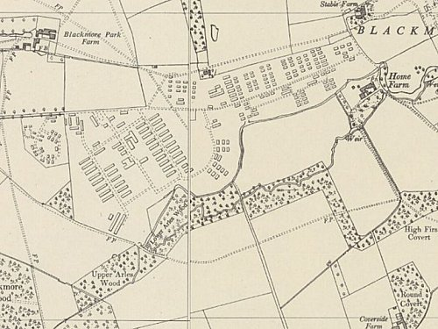
  Oversight and development of re-education activities and English teaching for German pows was carried out by PID (Political Intelligence Department of the Foreign Office) / COGA (Control Office for Germany and Austria – UK). Visits and reports were made. The standard of the reports varied greatly. The visitors took little interest, if any, in activities other than re-education. They rarely mentioned welfare, sports, games, pastimes, crafts, etc of the pows.
 | Ordnance Survey 1955

7-9 August 1946 – Location: Northend, Nr Leamington Spa, Warwicks. Report on re-education and progress at Camp 689 Pow Working Company.

Strength: 0 officers, 666 Other Ranks, at:

337 at HQ, Northend.
109 detached to Long Marston Camp 685. (See under camp 6).
125 at Craven Arms – 80 miles from HQ.
95 at Blackmore – 65 miles from HQ. NOTE that Blackmore is listed as a pow detachment / hostel.

Commandant: Major W Yeo Camp leader; Hpt Fw Frankl (B)
Interpreter: Sgt N La Salle Deputy C/L: Blackmore, Fw Brandt (B) / Craven Arms, S.Fw Rosin (B+)
No 2 i/c: Lt P A McGuffie (at Blackmore) German M.O.: Unterarzt Arens (est A).

It was recorded that the HQ was about to move, which had an unsettling effect.

The camp leader was; “an able man… he takes great interest in re-education.”

Political screening: | A+ | A | A- | B+ | B | B- | C+ | C | C- | Unscreened
 | 0 | 31 | 1 | 22 | 369 | 38 | 0 | 115 | 0 | 90

Morale was recorded as low due to a lack of activities. The only physical activity was football. The visitor believed that no political progress had been made.

50% of the pows at HQ were ‘youth’ (under 25), only 20% at the detachments. No special provision was made for them.

There were few re-educational activities, the camp had clearly been neglected by PID and the situation was very poor in comparison to most other camps. The standard list was given:

Wochenpost and Ausblick – Insufficient Wochenpost, 0 Ausblick.

Newspapers – A range of British papers received. No German papers sent by COGA.

Library – None.

Lectures – None.

Discussion groups – None.

Films – Supplied fortnightly by YMCA at HQ. Blackmore had only received 1 film, and 0 at Craven Arms though they were allowed to see films at the nearby Camp 84.

Wireless – Sets at all sites, but difficult to receive German stations.

Camp magazine – None. Hoped to start after the camp moved.

Press review – None.

English instruction – 48 pupils at HQ; 0 at Blackmore / Craven Arms.

Other camp activities –

Religion – RC Sunday services for 25/30 at HQ. Lack of interest for Protestant services. At Craven Arms pows could attend Ludlow church once a week. Blackmore held services for RC and Protestants.

Education – no classes.

Entertainment – None.

Note on Craven Arms – the pows were under the command of RASC as drivers / mechanics.

The camp moved to Blackmore shortly after this report.
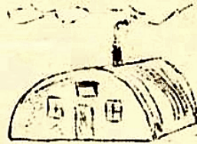
25 December 1946 – Camp magazine No.4 for Blackmore Pow camp; Blackmore Kurier : Lagerzeitung des Camps 689

After the camp: The ‘Traces of War’ website records that – “After the war, the water towers and a number of huts remained until the present day.” 2020 Industrial estate.

Further Information:

National Archive – FO 1120/246; 1 report, used above.

Air photographs - RAF 106G/UK/1354 7254-6 02-APR-1946 and 106G/UK/1652 4337-8 11-JUL-1946

For US Hospitals at the site see – Blackmore Park in World War Two – An account of the US Army hospitals at Blackmore Park, Malvern 1943-5 : F and M Collins : Brewin Books : 2008

