Camp 687 Shotover House, Wheatley, Oxfordshire

1947 Camp List
687(G.W.Coy) | S | Shotover House, Wheatley, Oxford | Oxford 3108 | 52(W.O.) | V/1270/4

Prisoner of War Camps (1939 – 1948) - Project report by Roger J.C. Thomas - English Heritage 2003
OS NGR | Sheet | No. | Name & Location | County | Cond’n | Type 1945 | Comments
SP 583 067 | 164 | 687 | Shotover House, Wheatley | Oxfordshire | 4 | German Working Camp | Parkland and road widening.

Location: About 7km to the E of Oxford. In the grounds rather than the house.  Before the camp:  Pow Camp:  5, 9 & 10 August 1946 – this was the 2nd visit by PID; the first report is not in the National Archive file.  Strength; 0 officers, 580 Other ranks.  Commandant: Major Topham; “very interested in re-education.”  Interpreter: None  Camp leader: Michelbach (B est). At the special training camp, Wilton Park.  Deputy C/L: Riedl (B), acting as leader, “young and lacks the necessary experience.”  German M.O.: None. | 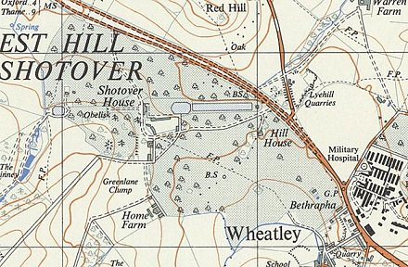
  Oversight and development of re-education activities and English teaching for German pows was carried out by PID (Political Intelligence Department of the Foreign Office) / COGA (Control Office for Germany and Austria – UK). Visits and reports were made. The standard of the reports varied greatly. The visitors took little interest, if any, in activities other than re-education. They rarely mentioned welfare, sports, games, pastimes, crafts, etc of the pows.
 | Ordnance Survey 1964

The former Camp leader, Oeltjen (A) had given up the post at his own request. There had been ‘intrigue’ by a German interpreter which had involved Oeltjen, but annoyingly no further details were given. The interpreter had been transferred to another camp.

Morale was considered to be good as the living conditions were, “very reasonable” and there was a lack of barbed wire. Few pows had been politically screened, so the report included estimated grades. There was a group of about 20-30 Nazis (C grade). There were few communists.

About 40% of the camp were ‘youth’ (under 25), they were not recorded as a problem.

A camp committee developed activities. The standard list of re-education activities was given:

Wochenpost and Ausblick – 90 / 0 copies received.

Newspapers – British and German papers received – no details of how many or how often.

Library – 130 books.

Lectures – Regular and popular.

Discussion groups – Political and Catholic discussion groups met weekly.

Films – Supplied by YMCA fortnightly.

Wireless – “Adequate,” but 2 more loudspeakers requested.

Camp magazine – None

Press review – None, but hoped to start.

English instruction – 40 pupils in 3 classes.

Other camp activities –

Religion – No padres. Some ‘local arrangements’ had been made.

Education – A French class.

Entertainment – An active theatre group. It was hoped an orchestra would start.

After this report a camp magazine was produced; ‘Brűcke zur Heimat.’

13 March 1947 – Re-education report. 3rd visit.

Same Commandant.

The Company was in the process of being disbanded. The number of pows had already decreased to 326 pows, from these 132 were being transferred to Harcourt Hill Camp 43, and 160 were ready to leave for Old Windmills Camp 632.

After the camp:

Further Information:

National Archive file – FO 1120/246, 2 reports used above.

