Camp 686 Moreton-on-Lugg, Hereford, Herefordshire

1947 Camp List
686(G.W.Coy) | W | 42 O.S.D. Moreton-on-Lugg, Hereford | Hereford 2576 Ext.25 or 35 | 29(W.O.) | V/1270/4

Prisoner of War Camps (1939 – 1948) - Project report by Roger J.C. Thomas - English Heritage 2003
OS NGR | Sheet | No. | Name & Location | County | Cond’n | Type 1945 | Comments
SO 5018 4601 | 149 | 686 | German Prisoner Working Camp (GPW Coy.), Moreton-on-Lugg | Herefordshire | 4 | German Working Camp | Housing and farmland.

Location: About 6km N of Hereford. At 42 O.S.D. = Ordnance Supply Depot.  Before the camp:  Pow Camp: Accommodation in Nissen huts.  March 1946 – Camp opened for German pows to provide labour at the OSD. The first 375 pows were brought from camps in the USA via a British camp in Oldham.  April 1946 – A further 170 pows, mainly ‘youth’ (under 25) arrived from Camps in Belgium (via Camp 199). Many of these pows had experienced extremely poor conditions.  1 / 4 July 1946 – Visit by the Segregation Section of PID, for political screening and to organise re-education. The visit had been requested by the Commandant.  686 German Working Company, based at 42 O.S.D. at Moreton-on-Lugg. Strength 0 officers, 533 Other Ranks. Another 36 were on detachment from Camp 677.  Commandant: Major L Stewart-Brown Camp Leader: Uffz Albert Keil (B+)  Interpreter: none Deputy C/L: O/Fw Erwin Lehmann (C). | 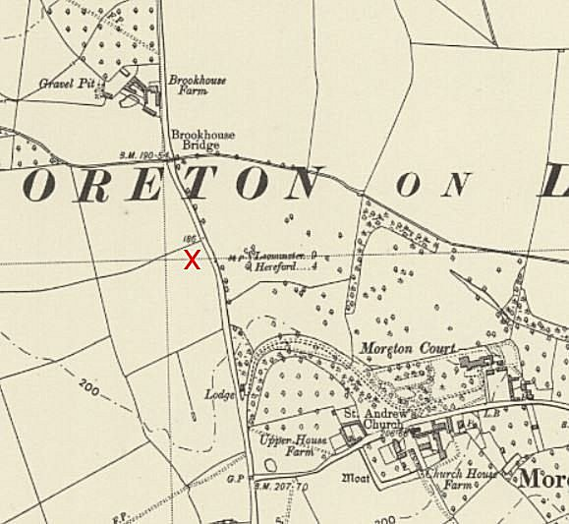
  Oversight and development of re-education activities and English teaching for German pows was carried out by PID (Political Intelligence Department of the Foreign Office) / COGA (Control Office for Germany and Austria – UK). Visits and reports were made. The standard of the reports varied greatly. The visitors took little interest, if any, in activities other than re-education. They rarely mentioned welfare, sports, games, pastimes, crafts, etc of the pows.
 | Ordnance Survey
Camp leader Keil, aged 28, a student of chemistry before signing up for service in 1936; “makes a good impression, is efficient at his job and seems suitable. Experiences some difficulty in coping with some of the bad characters in the camp owing mostly to his unusual sense of fairness.”

The deputy C/L, aged 32, “Appears lazy, incompetent and is a very poor type.”

The pow Chief of Police; O/Gefr Otto Ernst, aged 41, was also grade C (Nazi); “Very poor type.”

Political screening: | A+ | A | A- | B+ | B | B- | C | C+
 | - | 1 | - | 23 | 187 | 209 | 113 | -

Morale was described as poor. Most pows who arrived from the USA had been misinformed in the US that they were being repatriated; instead, they found themselves in working camps in the UK. News from home was also often depressing. Reports that Nazis were being employed in Germany (often true) made pows question why they were still being held. The visitor considered that little political progress had been made, especially amongst those that had arrived from the USA.

About 30% of pows were ‘youth’ – 50 were aged under 20. They were considered to be a problem as they were liable to fall under the bad influence from the older pows from the USA. The Commandant was trying to ensure that huts with youth pows had suitable older leaders.

The standard list of re-education activities was given, it was poor in comparison to many camps:

Wochenpost and Ausblick – separate appendix

Newspapers – 20 British dailies, some given by British officers, some purchased using the camp welfare fund (monies mainly raised through sales in the canteen). 12 German papers had been received “some time ago,” none since then.

Library – None.

Lectures – None.

Discussion groups – 9 pows had formed a group.

Films – Fortnightly supplied by YMCA.

Wireless – 1 camp set. 10 pows owned radios they had purchased in the USA.

Camp magazine – Planned to start. Paper and stencils needed.

Press review - None

English instruction – 70 pows, all beginners.

Other camp activities –

Religion – About 50/50 protestant and RC. Services held by local clergy.

Education – Small classes for French and Spanish.

Entertainment – The theatre group had presented one comedy. A small orchestra used instruments borrowed from the British, playing dance music.

21 July 1946 – Camp magazine No.1; Der Spiegel : Zeitschrift des Kriegsgefangenenlagers no. 686 Moreton-on-Lugg - The Wiener Holocaust Library

9 August 1946 – Notes from lecturer’s report. This was the first lecture given in the camp. 500 attended, though attendance fell for the next lectures. It was stated that when opened, the camp had been in a poor condition, but the pows had worked to improve this. He believed that morale had improved as the pows settled down.

28 September 1946 – Lecturer’s report. The first pow had been repatriated. Non-fraternisation rules were very strictly applied and an example was given that pows were not allowed to talk to members of the ATS even if on duty, except through one of the guards.

2 October 1946 – Lecturer’s report. Camp strength down to 490, (160 attending lecture). Some pows were starting to be employed at farms, mainly potato lifting.

January 1947 – record that RC Priest Josef Nibler from Greenfields Camp 48 visited this camp.

14 February 1947 – Lecturer’s report. Cold weather and a lack of coal to heat classrooms and lecture room. Serious issues were raised – regarding poor relationships between pows and guards, pows feeling abandoned in this camp, restrictions on walking out. The excessive use of non-fraternisation rules continued - while other pow camps were allowed access to Hereford, for pows from 686 it was held out of bounds.
19 March 1947 – Lecturer’s report. Repeated that morale was poor and that pows were not allowed the same freedoms as other pows elsewhere. Attendance at lectures down below 50.

8 – 10 April 1947 – Another visit by PID to ‘Organise re-education.’ Strength; 0 officers, 272 OR.

A very ‘inadequate’ report, lazy and with little or no reasons given for the poor situation and activities.

Commandant: Major L Stewart-Brown Camp Leader: W Hartmann (B-)
Interpreter: none Deputy C/L: A Pyttel (B)
German M.O.: Unterarzt W Vinke (B)

The camp leader had been newly appointed. A member of the Hitler Youth, then an engineering student. Had been held in camps in USA and Alaska. “Pleasing personality, politically sound, but with little initiative and powers of leadership.”

Deputy leader Pyttel; “A somewhat dreamy individual. Had been a member of the Hitler Youth and a strong Nazi, but no longer supported them and had considered suicide.

Political screening: | A | B+ | B | B- | C
 | 0 | 13 | 85 | 114 | 60

58 pows were appealing against their political grades; the better the grade, the sooner repatriated, in theory. 98 pows repatriated to date.

The PID visitor stated that morale was ‘fair’ and that the pows received good treatment from the camp staff. It was stated that the pows were able to take “walks in a pleasant locality after work” – no reference to being allowed access to Hereford.

24% were ‘youth,’ they were no longer considered to be a problem.

It was noted that re-education had declined considerably during the last two months due to; leaders being repatriated, cold weather and lack of fuel, “Withdrawal of accommodation used for re-educational activities;” no reason was given for this last factor.

Wochenpost and Ausblick – separate appendix.

Newspapers – “Adequate.”

Library – A good stock of books.

Lectures “Adequate.”

Discussion groups – ended, hoped to restart.

Films – “Adequate.”

Wireless – “Adequate.”

Camp magazine – A small number of contributors. 80 copies issued, but did not state how often.

Press review – None

English instruction – separate appendix.

Information room – “Very inadequate.”

Other camp activities –

Religion – Services were held in an “attractive camp chapel.” Outside clergy and pow padres from other camps gave services.

Entertainments – “A good theatre group can no longer function owing to withdrawal of accommodation” – no reason given for this. Most orchestra members had been repatriated. Sport was popular and facilities were good.

It was expected that the camp would be closed by the end of June.

30 April 1947 – lecturer’s report. Camp down to 100 pows.

18 May 1947 – last report of a lecture. The camp closed soon after.

After the camp:

Further Information:

National Archives – FO 939/324 - 686 Working Camp, Moreton-on-Lugg Camp, Hereford. Dated 1946 – 1947. Used above.

