Camp 679 - 083 Ordnance Supply Depot (OSD), Wem, Shropshire (aka Aston Park Camp)

1947 Camp List
679(G.W.Coy) | W | 83 O.S.D. (Don). Wem, Shrewsbury, Shropshire | Wem 200 Ext.27 | 23(W.O.) | V/1270/4

Prisoner of War Camps (1939 – 1948) - Project report by Roger J.C. Thomas - English Heritage 2003
OS NGR | Sheet | No. | Name & Location | County | Cond’n | Type 1945 | Comments
SJ 523 294 | 126 | 679 | 83 Ordnance Supply Depot (O.S.D.) (Don), Soulton Road, Wem | Shropshire | 4 | German Working Camp | Irregular fenced compound around a pre-existing camp consisting of nine groups of six curved profile huts. Farmland and housing.

Location: On the NE edge of Wem. 1947 - Aerial Photo | Historic England  Before the camp: The large Wem depot was built in 1942 / 43 as part of Operation Bolero for building-up US troops and supplies within the UK.  Pow Camp:  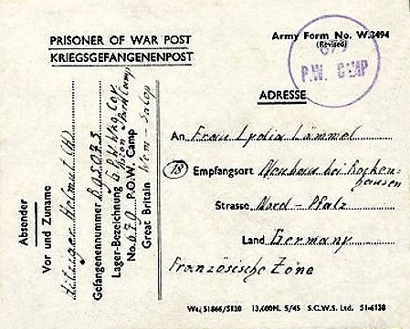  Heritage entry (PRN 29140): Second World War prisoner of war camp at Soulton Road, co-located with the US Army 83 Ordnance Supply Depot. It was set up on an existing camp comprising 9 groups of six curved profile huts enclosed by an irregular-shaped fence.  On May 1st 1945, when the end of the war in Europe was only days away, Corporal Friedrich Wolter and Grenadier Erich Mullenhord [Wullenkord] tried to escape and were shot dead as they rushed a guard at the US base as he was opening a warehouse door. They were buried at Wem Parish Church. It was in use up until 1948.  The two pows who were shot were later re-buried at the Cannock Chase German War Cemetery.  < 1946 pow postcard – note use of address ‘Aston Park Camp’, the name of the site on the map. | 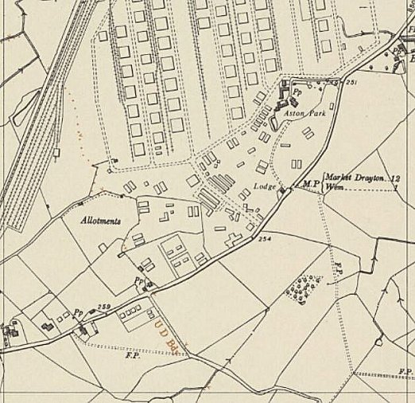
 | Ordnance Survey 1954
Spring 1945 – Camp list; “German Working Company, 679, W(est), O.S.D. (DON), Wem, Salop,” with a War Establishment code of V/1270/1 (camp with under 1000 pows).

April 1946 – Camp Magazine No.7; Lagerecho : P.W. Wkg Coy. 679 : Unterhaltung fur Alle - The Wiener Holocaust Library

After the camp:
Further Information:

