Camp 678 Fort Crosby, Hightown, Lancashire (+ Bluebell Lane)

1947 Camp List
678(G.W.Coy) | W | Fort Crosby, Hightown, Nr.Liverpool, Lancs | Hightown 192 | 65(W.O.) | V/1456/2

Prisoner of War Camps (1939 – 1948) - Project report by Roger J.C. Thomas - English Heritage 2003
OS NGR | Sheet | No. | Name & Location | County | Cond’n | Type 1945 | Comments
SD 296 025 | 108 | 678 | Fort Crosby, Sniggery Farm, Hightown | Lancashire (Merseyside) | 4 | German Working Camp | Camp associated with former coast artillery battery & heavy anti-aircraft battery. Sand dunes.

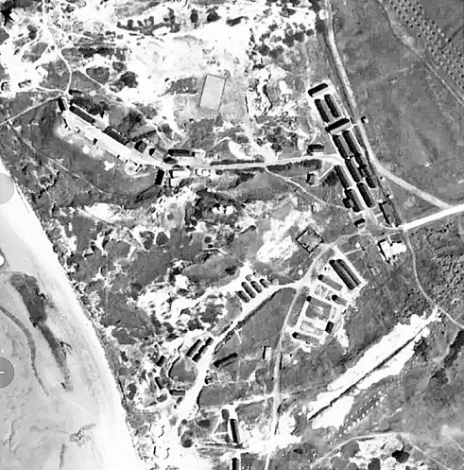  Location: About 6km N of Crosby. Alongside Sniggery Farm, (sniggeries were eel ponds).  1945 aerial photo; Aerial Photo | Historic England  Before the camp: Fort Crosby opened in 1906. The site was surrounded by high, barbed wire fences. The accommodation camp (Sniggery Barracks) for soldiers was across the railway on land belonging to Sniggery Farm.  Pow Camp:  678 Bluebell Lane  Memories recall Italian pows possibly as early as 1943, later Germans.  Early Spring 1945 – Camp list; “German Working Camp, 678, W(est), Bluebell Lane camp, Huyton, Liverpool,” with a War Establishment code of V/1270/1 (camp with under 1000 pows). See map below. | 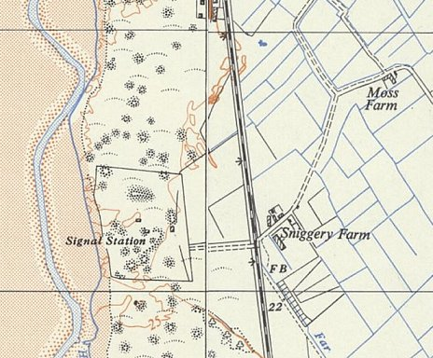
 | Ordnance Survey 1957
“After D Day, all the Americans left to fight the war in Europe, and their place in the Bluebell Lane Camp was occupied by Italian prisoners of war.
.
In 1945, when it became obvious that the war was won, a decision was made to let the Italians out for a few hours in the evening. They wore maroon uniforms with a large lemon diamond on the back, and like the Americans before them were a huge attraction to the local girls. Our soldiers, who had been sent home to rest and recuperate after being wounded in Europe, were incensed to find many of the unattached females consorting with the Italians, holding hands and strolling the sunlit lanes, or sitting in the back row of the Mayfair cinema watching George Formby. This lead to a certain amount of animosity, particularly in the Rose and Crown on a Saturday night! While our soldiers were fighting in Salerno and Monte Cassino to free Italy from the oppressor, these Italians were safe, secure, watered and fed in the green fields of Huyton.”

https://www.bbc.co.uk/history/ww2peopleswar/stories/51/a4517651.shtml

There was also an internment camp and a US army camp in Bluebell Lane.

678 Fort Crosby

“The camp at Fort Crosby was adapted from an existing installation and was situated at the western end of the road leading from the main entrance (now adjacent to the railway). Fort Crosby was used as a camp for a German Working Company and also housed working Italian PoWs from 1945 until 1950. [After 1948 the camp was no longer classed as a pow camp.]

Prisoners were housed in wooden huts, each accommodating 20 men. They were situated adjacent to the football field at Fort Crosby and were separated from the fort by a barbed wire fence and a guarded gateway.

Some prisoners were soldiers who became displaced people towards the end of the war due to political changes at home. Unable to return home, they lived at the camp for some time before being resettled. They were guarded by Polish soldiers, who had their own accommodation on the site, to the south west of the prisoners’ huts. The area of hard standing to the front of these buildings can still be traced in the tarmac that remains on site. As a working camp, prisoners were engaged in construction projects and worked at local farms, returning to the camp at night.

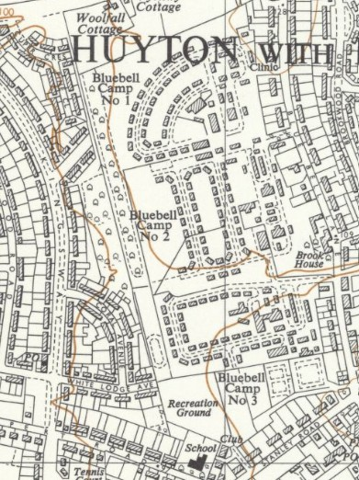
In their spare time, the PoWs played sports and made toys which they sold from a small hut near the station at Hightown. The camp also had a cinema, open to both prisoners and non-residents of the camp, which showed German films on a Tuesday night and English films on a Thursday. The films shown were very popular and were well attended by local people, who walked to the fort from both Hightown and Crosby.” Extract - See Alison Burns’ book; link below.
The footballer, Bert Trautmann, was a pow for a short time at this camp.

Closed 1948

After the camp: From 1950 to 1954 used by the Territorial Army. The Fort closed in 1957. Demolished 1967.

Further Information:

Fort Crosby: Dune Heritage Revealed – Alison Burns - Sefton Coast Landscape Partnership – 2015 – available from: www.academia.edu/17314554/Forgotten_Fort_Crosby_Dune_Heritage_Revealed

Ordnance Survey 1954 >

