Camp 675 Hiltingbury Road, Chandler's Ford, Eastleigh, Hampshire

Prisoner of War Camps (1939 – 1948) - Project report by Roger J.C. Thomas - English Heritage 2003
OS NGR | Sheet | No. | Name & Location | County | Cond’n | Type 1945 | Comments
SU 4289 1887 | 185 | 675 | Hiltingbury Road, Chandler's Ford, Eastleigh | Hampshire | 4 |  | Industrial area.

Note - The English Heritage entry is confusing. Hiltingbury Road was Camp 675. However, the NGR given is NOT for that site, but for Camp 614, located about 3.5km SW.

Location: NGR SU 433 224  1953 aerial photo showing many huts in the area: Aerial Photo | Historic England  POW Camp:  Spring 1945 – Camp list: “German Working Company, 675, S(outh), No.3 National Service Hostel, Hiltingbury Road, Chandlers Ford, Hants,” with a War Establishment code of V/1270/1; a camp with under 1000 pows.  25 June 1945 – Progress Report 112 by the Segregation Section of PID (Political Intelligence Department of the Foreign Office).  “We have supplied D.P.W. [Department for Prisoners of War] with nominal rolls for 525 ‘A’s’ and ‘B’s’ to form the new Working Company No.675 at Hiltingbury, Southampton.  These Ps/W were drawn from the ‘white’ compound at Colchester Camp No. 186.”  A and B refers to the political grades for pows; ranging ‘A’ non-Nazi to ‘C’ Nazi.  September 1945 – Appendix to HQ Southern Command War Diary; “675 – Hiltingbury Road, Chandlers Ford – German working company – capacity 550.”  9 May 1946 – A report from a visiting lecturer in National Archive File FO 939/322; | 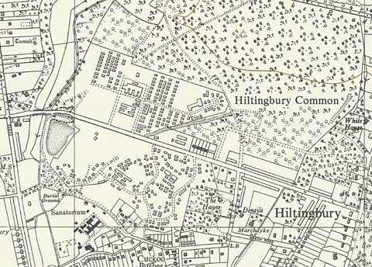
 | OS 1963 – Hiltingbury Road, huts on both sides of the road
“Detachment on the Fort [Warden] in Freshwater, Colwell Common, Isle of Wight; detached from Camp 675, Chandlers Ford.” 54 pows attended his lecture which was all the pows in the detachment.

The detachment raised various justified complaints; they stated that they were not Nazis, but were still escorted to and from work, they were not allowed to bathe in the sea, they were not allowed a short walk outside of the barbed wire, they had not had a cinema visit, no wireless or newspapers…. This was shabby treatment in comparison to that received by most pows. They were generally depressed and repatriation was always on their minds. An example was given of an anti-Nazi, ex communist, aged 53, who had been forced to work for the Organisation Todt on the Channel Islands.

10 October 1946 – Camp magazine; Rundschau : Lagerzeitung 675 Kriegsgefangenenlager - The Wiener Holocaust Library

Mentions sports matches against Willems Barracks Camp 1006 and Old Dean Common Camp 1016.

“Effective October 1, 1946, 25 men each from Camps 671 and 1006 were transferred to the 675th G.P.W. Coy. These men have already been part of our ‘Isle of Wight’ detachment for some time. Regarding all matters, the newly arrived men will be treated exactly as the long-standing members of this camp are accustomed to. The Commandant himself announced this policy during his last visit to the island.”

Fort Warden – Detachment or Hostel?

The report above referred to the site as a detachment, but a later report from Camp 65 called it a hostel:

Information from a report for Setley Camp 65 dated June 1947 – Kurt Rudolf Boerner (B), aged 35, married, from the American zone, had been appointed hostel leader in January 1947. The hostel and its pows were then transferred to Camp 65 in April 1947. “They appear to have been somewhat neglected and are resentful. In addition, their work is unusually arduous and trying.”

