Camp 674 / 675 / 1016 Old Dean Common Camp, Camberley, Bagshot, Surrey

1947 Camp List
675(G.W.Coy) | S | Old Dean Common Camp, Camberley, Surrey | Camberley 155 | 30(W.O.) | V/1270/4
1016(G.Wkg.Coy) | S | Old Dean Common, Camberley, Surrey | Camberley 1154 | 30 | V/1270/4

Prisoner of War Camps (1939 – 1948) - Project report by Roger J.C. Thomas - English Heritage 2003
OS NGR | Sheet | No. | Name & Location | County | Cond’n | Type 1945 | Comments
SU 8849 6173 | 175 | 674 / 675 | Old Dean Common Camp, Camberley, Bagshot | Surrey | 4 | German Working Camp | Site occupied by housing.
SU 8837 6218 | 175 | 1016 | Old Dean Common Camp, Camberley, Bagshot | Surrey | 5 | German Working Camp | Precise location not identified. NGR for Common

NOTE – the two camps were separate. However, with the same name and NGRs less than 0.5km away, at the moment I have put details for both on these pages.

Location: From memories, 1 site was at Old Dean, the other on the edge of Chobham Common.  Before the camp: Military buildings in the area were used by free French Forces before D-day.  Pow Camp:  Camp Magazine - “Richard Höhne of Camp 674 at Bagshot in Surrey called his paper Zuspruch (encouragement) and its first issue explains his choice of title as comforting and encouraging, reminding his readers of the saying that ‘it helps to talk to one another’. He began his first editorial: ‘The child has been given a name! That was almost the hardest task’, that is, to set the direction the paper was to take. Höhne had compiled the first ten-page issue of Zuspruch single-handedly, inter- spersing his articles with three pages of a Wilton Park lecture on ‘German foreign policy 1939–45’, a one-page article by Harold Nicholson on ‘German POWs in England’, a diary page from the Stratton Factory Camp, and a poem and short texts by famous German authors. But he needed contributors, and asked for them to come forward.” [Article in German Historical Institute London Bulletin, Vol XXX, No.2, November 2008 by Ingeborg F. Hellen]  Camp magazine 1016 – Der Ring  1 August 1947 – Old Dean Camp 675 became a hostel for East Cams Camp 251.  October 1947 - a detachment from this camp was sent to the Isle of Wight. | 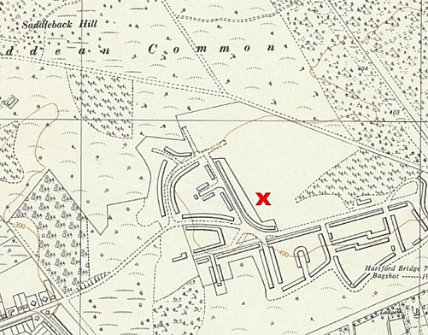
 | Ordnance Survey 1961
January 1948 – details for East Cams camp 251 stated that the camp leader from 1016 had been transferred there on the recommendation of the Old Dean hostel leader.

After the camp:

Further Information:

A lot of information about PoW camps on Old Dean Common & Chobham Common, including Lidar images - https://www.bagshotvillage.org.uk/know/pow.shtml

