Camp 673 Home Park Camp, Plymouth, Devon

1947 Camp List
673(G.W.Coy) | S | Home Park Camp, Plymouth | Plymouth 60922 | 37(W.O.) | V/1270/4

Prisoner of War Camps (1939 – 1948) - Project report by Roger J.C. Thomas - English Heritage 2003
OS NGR | Sheet | No. | Name & Location | County | Cond’n | Type 1945 | Comments
SX 4591 5655 | 201 | 673 | Home Park Camp, Plymouth | Devon | 4 | German Working Camp

Location: The NGR above is in a housing area established well before the war. ‘Home Park’ is the name given to Plymouth Argyle’s football stadium within Central Park, Plymouth, slightly to the E at NGR SX 4719 5644. A brief reference in the Plymouth Herald stated the camp was in, “Central Park (southern end)”  Before the camp:  Pow Camp:  21 April 1946 – Camp magazine No.4; Das Inselschiff : Lagerzeitung des Camp 673 - The Wiener Holocaust Library  After the camp:  Further Information: | 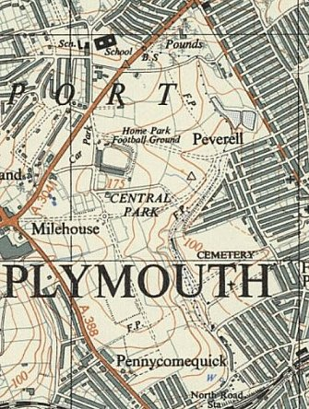
 | Ordnance Survey 1947

