Camp 671 Popham and Lockerley Camp, Winchester, Hampshire (Popham aka Micheldever)

Prisoner of War Camps (1939 – 1948) - Project report by Roger J.C. Thomas - English Heritage 2003
OS NGR | Sheet | No. | Name & Location | County | Cond’n | Type 1945 | Comments
SU 5593 4371 | 185 | 671 | Popham Camp, Micheldever, Winchester | Hampshire | 5 | German  Working Camp | Precise location not identified. NGR for  centre of village.

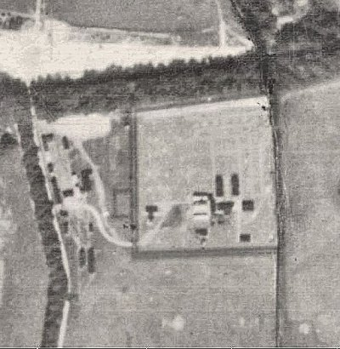  Location: Martin J Richards carried out field research to locate the Popham (Micheldever) camp. He placed it at NGR SU 5229 4358. 1947 aerial map: View map: Ordnance Survey, OS Air Photo, 6 inch to the mile (1:10,560), Sheet 41/54 S.W. - Ordnance Survey Air Photo Mosaics, 1944-1950  Before the camp:  Pow Camp:  May 1945 – Camp list; “German Working Company, 671, S(outh), Popham Camp, Micheldever, Hants,” with a War Establishment code; V/1270/1. | 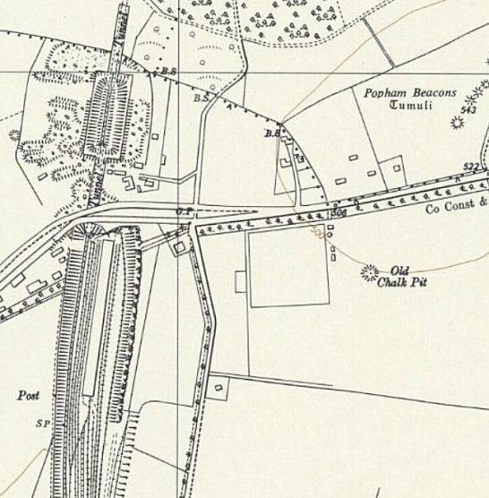
  Oversight and development of re-education activities and English teaching for German pows was carried out by PID (Political Intelligence Department of the Foreign Office) / COGA (Control Office for Germany and Austria – UK). Visits and reports were made. The standard of the reports varied greatly. The visitors took little interest, if any, in activities other than re-education. They rarely mentioned welfare, sports, games, pastimes, crafts, etc of the pows. If there were still Italian pows in hostels, they were usually ignored by PID.
 | Ordnance Survey 1961
15-17 June 1945 – Initial visit stated that the camp was opened on 30 May. Strength; very difficult to read as blurred, appears to be 365 or 565.

Commandant: Major F Sutcliffe; “a young man and very keen on re-education.” Camp leader: St.Wm Schoenroch
Interpreter: None Deputy leader: St.Fwbl Vogelsang
German M.O.: Brendel

There was a single compound with pows accommodated 15 to each bell tent; overcrowding was noted. Paths were being laid out and the Commandant wished to encourage flower beds and potato patches.

Employment was unusual; 200 worked at a ‘canine quarantine station.’ 2 more groups of 40-60 were reconstituting a river bed used for ‘water proofing tanks.’

Morale was recorded as low. Most pows had been transferred from Camp 5 which was hutted, and at the same time there was a general cut to rations. No mail from their families in Germany had been received. There was a lack of amenities at the site.

Political grading of the pows had not been carried out. The camp leader and deputy had supported National Socialism, but were declared to be not interested in politics. They were noted as being “excellent disciplinarians.”
The compulsary film about concentration camps was shown during this visit:

“The Commandant and I saw the first show and then watched succeeding groups as they came out. Almost all were silient and glum, some even managed a tear or two. I picked every tenth man and asked him three questions. 1. Did he believe them true? 2. What did he think about these attrocities? And 3. Who was responsible?

Without exception they replied: 1. True. 2. Shocked and disgusted and 3. The Government (Fuehrung) mostly adding: “Der kleine Mann wueste davon nichts.” [The little man knew nothing about it.]

Out of the next groups we picked out those (all youngsters) who were laughing as they came out. Their answer was in all but one case: Propaganda, the one was frightened, otherwise he would have replied the same.

On Sunday morning I spoke to the Doctor who gave me the gist of the feeling of the Nazis. ‘We have seen too much propaganda, why should this not be; everything can be faked. Perhaps they were starving only because of supply difficulties; I think they must have photographed corpses from bombed houses.’ The strongest reason for disbelief was the shot of the British prisoners, as all had seen so many of these well fed. The strongest argument for the truth of the film was put forward by the Camp Leader. “A leadership which did not hesitate to send thousands of Germans to useless death when the war was lost, would not hesitate to exterminate thus the enemies of the regime.” Not even the young Nazis say they would feel indifferent if the film was authentic. Many asked for interviews with SS warders and their excuses to be published. This would convince them.”

Basic details of activties were given:

Wochenpost – considered by most as propaganda, given nickname of ‘Wochenpest.’

Ausblick – Considered to be ‘above the heads’ of most pows.

Newspapers – 1 British newspaper was received.

Wireless – 1 new set installed.

Religion – Services held in camp every Sunday.

Recreation – None. Basic items such as a football, books and a pack of cards were requested.

Education – classes started for English, German, French, arithmetic, history, physics and electrical engineering.

Entertainment – a choir had formed.

9-11 August 1945 – General visit.

Bell tents and a few marquees. Some buildings for general use. Comments made that the accommodation for dogs was better than for pows. No electricity, hurricane lamps used. No clothing had been issued.

News of the atom bombs had many stating that this was a “Kriegsverbrechen” [war crime] as much as any for which war criminals were awaiting trial.

September 1945 – Appendix to HQ Southern Command War Diary; “671 Popham camp, Micheldever – German working company – capacity 550.”

November 1945 – A visiting lecturer commented that facilities at the camp were poor.

1946 – Intake of pows from camps in the USA. Most had a very low morale as they had been misinformed in the US they were being repatriated. Instead, they found themselves in working camps in the UK.

8 March 1946 – Camp magazine No.7 (The Open Gate); Das Offene Tor : Lagerzeitung 671 (G) PWW Coy - The Wiener Holocaust Library

Camp padre; Werner Wolf. Mention of a football match against Stoneham Camp 614. At some point there was a different title; Unsere Zeitung (Our News).

May 1946 – a lecturer’s report mentioned a pow hostel at Lockerley.

June 1946 – From a lecturer’s report: Popham still under canvas. An extremely well-run camp, but he considered that many of the pows were still Nazis.

His lecture at Lockerley hostel was affected by a search of pow belongings.

June 1946 – Padre Wolf visited a hostel attached to Ganger Camp 41 and other sites.

17/18 July 1946 – Progress report. Strength; 1 officer (the M.O.), 459 Other Ranks at all sites (see chart below).

Commandant: Major Hoskins Camp leader: St.Wm Schoenroch (B)
Interpreter: L/Cpl Rogers Deputy leader: St.Fwbl Vogelsang (B).
German M.O.: St.Arzt Brendel (B)
Little use was made of the Interpreter – the Commandant had little regard for him.

The camp leader was described as; “a professional soldier, a competent sergeant-major, co-operative, but quite incapable of intellectual leadership.” His deputy was described as similar; “but less intelligent.”

Political screening: | A | B+ | B | C | Unscreened
 | 63 | 2 | 339 | 39 | 17

Morale was high as repatriations started and the first 5 pows had left the camp. The visitor believed that little political progress had been made.

There was a particular cause for complaint at the main camp. The site was still tented, without electricity and heavily wired. Within ½ mile was a pow hostel attached to Ganger Camp 41 holding many ex-SS which was hutted, had little barbed wire, minimal guards and many pows were allowed to use bicycles. It was bad for morale that the Nazis had better living conditions than those allowed for Camp 671.

About 40% of the pows were ‘youth’ (under 25), they were not considered to be a problem.

The standard list of re-education activities was given;

Wochenpost and Ausblick – 100 / 50 copies.

Newspapers – 3 or 4 English papers bought daily. COGA supplied 2 weekly papers and some German papers.

Library – 800 books, but 450 were text books.

Lectures – Regular and generally popular.

Discussion groups – Excellent, also a Brains Trust.

Films – Regularly supplied by YMCA and COGA

Wireless – 1 set and 8 loudspeakers at main, but poor reception.

Camp magazine - fortnightly

Press review – None recorded for the main camp.

English instruction – Separate appendix.

Other camp activities –

Religion – Protestant padre, San Uffz Wolf (A); “generally respected and is a good influence.” An English RC priest visited on Sundays

Education – Classes for French, Russian, German, arithmetic and shorthand.

Theatre – an active theatre group

15 August 1948 – Camp magazine No.18 is contained in the National Archive file. It included a page for camp news:

“Special bulletin on camp activities:

5. Lecture: “Economic Reconstruction in Western Europe” (Mr. Liebreich).
7. Film: “The Young Mr. Pitt” (English feature film).
8. Film: “Hauptsache glücklich” [Main Thing: Happiness] starring Heinz Rühmann and Herta Feiler.
11. Training session: “We Talk English” with Capt. Martin.
13. Brains Trust.
14. Press: Newspaper review. Light music.
20. Film: “Welt im Bild” [World in Pictures] and “Country Town” (English documentary).
21. Press: Newspaper review.
22. Film: “Said O’Reilly to McNab” (English feature film).
27. Drama group: “Der Maulkorn” [The Muzzle] – a comedy based on the novel of the same name...
28. “ ...by Heinz Sperl, adapted by Kurt Bluhm.
29 “

On July 3rd, the 100,000th loaf of bread left our camp bakery.

Hospital: Ernst Bischof was transferred to Connaught Hospital, Knaphill, on July 30.

Transfers: The following comrades were transferred on July 16 to serve as cooks in hospitals:
Krueger, Plewka, and Kutzke to Camp 1006
Hirsch, Helexa, and Kichstein to Camp 614.

Repatriations:
July 21: Paul Jochheim to the British Zone.
August 1: Robert Colditz, Josef Buschitz, Georg Gierlinger, and Friedrich Holzinger to Austria.”

20 August 1946 – A visiting lecturer submitted a report which raised various issues. He stated that there was need for an education officer and that the pows had too little to do. Most pows worked in army camps and spent most of the day playing cards or passing time with other activities. He sent a copy of the last camp magazine to PID pointing out that some of the political articles were anti-democracy, and questioned why this was allowed.

15 September 1946 - Camp magazine No.20 is contained in the National Archive file. The camp activity list was very similar to the one above, there had been matches against camps 614, 675, 1006 and 1019; there had also been an athletics event at the main camp.

October 1946 – The HQ was transferred to the Lockerley site. The Commandant was replaced shortly after the move. Many pows were happy to transfer from the tented Popham / Micheldever site.

10-12 December 1946 – Progress report. Strength; 1 officer, 356 OR at HQ, 2 hostels and 3 detachments.

Note – Micheldever was no longer listed; it probably closed as it was tented, but it may have been transferred as a hostel to a different camp.

Commandant: Major Swain Camp leader: St.Wm Schoenroch (B)
Interpreter: None Deputy leader: St.Fwbl Vogelsang (B).
German M.O.: St.Arzt Brendel (B)
A German pow, Sold Haja (B) was being used as interpreter. He had been a member of the Nazi Party and was not trusted.

The M.O. was a good influence, he gave lectures and assisted the ‘Brains Trust.’

Political screening: | A | B | C | C+ | Unscreened
 | 20 | 267 | 65 | 4 | 1

78 pows were appealing against their political grades; the better the grade, the sooner repatriated, in theory. The Camp Leader, deputy and interpreter appealed against their grades, expecting to be graded ‘A’ – the visitor stated they stood no chance of this.

Approximately 160 pows repatriated to date.

Morale was regarded as being low. Slow repatriation and remaining grievances over conditions that had existed at Micheldever were cited as the main issues.

The list of re-education activities was very similar to the last report, except that discussion groups had ended due to repatriation of its leaders.

Other camp activities –

Religion – no change. Padre Wolf had transferred from Micheldever.

Education – Classes for French, German and English

Entertainment – No theatre or orchestra due to repatriations.

After the camp: 2020 farmland.

Further Information:

The German Federal Archives have copies of the camp magazines, unknown dates..

National Archive – FO 939/322. Used above.

POW NUMBERS

 | Open |  |  | With other camps |  |  | Unknown |  |  | Not open

 |  | 6/1945 | 9/1945 | 5/1946 | 7/1946 | 12/1946
Micheldever |  | 365 / 565? | Cap 550 |  | 298
Lockerley |  |  |  |  | 114 | 164
Moody’s Down Farm |  |  |  |  |  | 115
Whitchurch |  |  |  |  |  | 56
Detached - Sunningdale |  |  |  |  | 23 | 19
Detached – Isle of Wight |  |  |  |  | 25
Detached – Barton Stacey |  |  |  |  |  | 3
Billets | 0
TOTALS |  | ? | Cap 550 | ? | 460 | 357

Hostels

Lockerley. Hutted. Part of a former army camp. Large army base at NGR SU 298 274.

7/1946 – Hostel leader; O/Wm Bittner (B), “professional soldier, co-operative, but with only an elementary education.”

3 English newspapers purchased. 1 wireless which was out of order.

Daily press reviews given by the German Interpreter, Uffz Hoerrens (C). The visitor did not trust him.

10/1946 – Became HQ, see above.

Moody’s Farm. Rural farmland in Hampshire, near Barton Stacey and Winchester; situated off the B3420. NGR for the farm; SU 430 389.

12/1946 – Hostel leader; O.Wm Bittner (B), professional soldier, unpolitical, cooperative and efficient.

Whitchurch

NOTE – Camp 41 also had a Whitchurch hostel – this was separate.

12/1946 – Hostel leader; O.Faehnrich Meischein (C). Despite his C grade (Nazi), he was considered to be an efficient leader, intelligent and co-operative. A high number of Grade C pows, but there were no particular problems listed.

