Camp 670 St Radigund’s Camp, Dover, Kent (aka Radegund / Radigrund)

1947 Camp List
670(G.W.Coy) | E | St.Radigunds Camp, Dover, Kent | Dover 816 | 33(W.O.) | V/1270/4

Prisoner of War Camps (1939 – 1948) - Project report by Roger J.C. Thomas - English Heritage 2003
OS NGR | Sheet | No. | Name & Location | County | Cond’n | Type 1945 | Comments
 | 179 | 670 | St Radigrund's Camp, Dover | Kent | 5 | German Working Camp | Unresolved four possible sites.

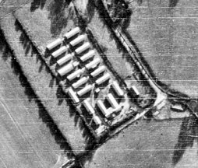  Location: kentonline website states that the camp was in the grounds of St Radigund’s Abbey at NGR TR 275 418.  (St Radigund’s is also a ward in Dover).  1946 aerial photo - Aerial Photo | Historic England  Before the camp: D4 heavy anti-aircraft site was located on high ground to the N of the Abbey site.  Pow Camp:  One English inspector’s report is held in National Archive File FO 939/185. The inspectors met teachers, gave talks, checked teaching texts and resources, and tested the pow pupils:  11/12 April 1947 – English Inspector’s Report – 670 German Working Company. Strength; 569. Hutted.  Main camp – 229; Hostels – Shorncliffe 288; Wouldham (Chatham) 52.  21 pupils in 3 classes at main. Lessons carried out in the canteen.  Details; “Two hostels, of which Shorncliffe used to be the main camp, while the present main camp at St Radigunds used to be a hostel of 1002 Coy., and the other hostel taken over on 6/4, was until recently a hostel of 644 Coy which is now being disbanded.” This refers in both cases to Hothfield Camp – originally 1002 and then 654 (not 644). | 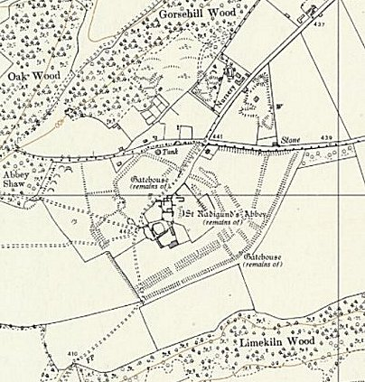
 | Ordnance Survey 1962

May 1947 – noted in a report for Normanhurst Camp 145, that this camp had been disbanded and the staff transferred there.

After the camp: St Radigund’s Abbey Farm.

Further Information:

Hostels

Shorncliffe. (670A) Hutted. Was independent Camp 33.

April 1947 – 288 pows. 26 studying English in 2 classes.

“An excellent hostel – every week three soldiers from the Army Education Centre come and give talks in English, and once a week a Schoolmaster from Folkestone Grammar School come in to give talks in English.”

April 1948 – listed as a hostel for Walderslade camp 117.

Wouldham. Hutted. (AKA RE Bridging Camp).

April 1947 – 52 pows, hostel recently transferred from Hothfield Camp 654.

June 1947 – recorded with Walderslade Camp 117. Closed early 1948.

