Camp 670 (& 680, & 740?) Shaftesbury Camp, Dovercourt, Essex

1947 Camp List
680(G.W.Coy) | E | Shaftesbury Camp, Dovercourt, Essex | Harwich 416 Ext.12 | 71(W.O.) | V/1270/4

Prisoner of War Camps (1939 – 1948) - Project report by Roger J.C. Thomas - English Heritage 2003
OS NGR | Sheet | No. | Name & Location | County | Cond’n | Type 1945 | Comments
TM 2391 3020 | 169 | 670b | Shaftesbury Camp, Dovercourt, Harwich | Essex | 4 |  | Site occupied by housing. See Camp no.680.
TM 244 302 | 169 | 680 | Shaftesbury Camp, Dovercourt, Harwich | Essex | 4 | German Working Company | See 670b

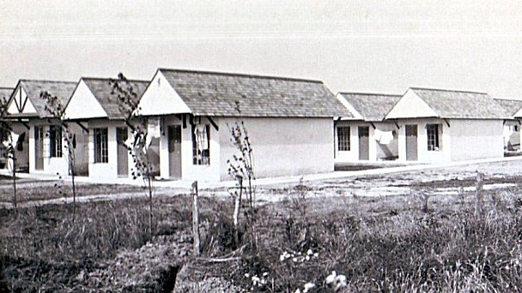  Location: 670 at x on map / 680 at y. 2 camps.  1948 Aerial photo: Aerial Photo | Historic England  Before the camp: In 1937 Harwich Borough Council bought the land at ‘y’ and leased it to the Dovercourt Bay Holiday Camp and Lido. Known as Warner’s Holiday camp.  Towards the end of 1938 the camp was used by the Refugee Children’s Movement to accommodate Kindertransport children.  At the start of the war the camp was requisitioned for military use.  Pow Camp: Became a pow camp in 1942.  Spring 1945 - Camp list; “German Working Company, 670, E(ast), Shaftesbury Camp, Dovercourt, Essex” with a War Establishment code of V/1270/1.  AND, the same details for Camp 680. | 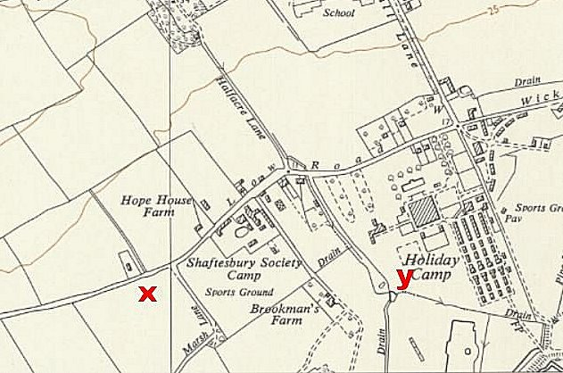
 | Ordnance Survey 1958
4 September 1945 – A very poor International Red Cross Report – below. NOTE; 2 camps, but under 1 Commandant.

May 1946 – Camp magazine No.1 for 680 (The Tent); Das Zelt : Monatsblatt des Lagers 680 - The Wiener Holocaust Library. Camp leader listed as Jungjohann. Mentions the sports rivalry between camps 670 and 680.

June 1946 – Camp magazine No.1 for 670; Lagerecho : Monatszeitschrift der 670 (G) P.W.W. Coy - The Wiener Holocaust Library. Camp leader; Deuerling. Also mentions sports results between 670 and 680.

4 March 1947 - As part of the re-education programme administered by the Control Office for Germany and Austria (COGA), Paul Bondy, a German-speaking refugee gave lectures at Camp 680.

After the camp: Re-opened as a holiday camp. Site used for BBC comedy Hi-de-Hi. Closed in 1990 and demolished in 1992. 2020 residential area.

Further Information: The German Federal Archives has a copy of the camp magazine.

ICRC Report on two "Working Companies"  (No. 670 and 680 / Dovercourt)  (Nr. 3462 from 4. 9. 1945)  C/JRh/MB Great Britain  "WORKING CAMPS” (670/680)  Visited 4 September 1945  Address: German Working Companies 670 & 680, G.B.  Commandant: Major R H Bishop  Camp leader: 670 DEVERLING, Max, ‘Stabsfw.’ 633478  680 JUNGJOHANN, Hans, ‘Hptfw.’ 169320  Capacity: 1200  Actual strength: 1079 German prisoners, comprising:  46 in the administration  1033 workers  General comments  This camp consists entirely of tents; the two companies are under the same command, with  a camp leader for each. This camp has held [German] prisoners since 13 June, 1945. It is very well situated, facing south towards the sea.  The kitchen, infirmary and refectories are fitted out inside large tents; 8 men are accommodated per tent. The tents have a floor; each prisoner has a palliasse and three blankets. To prevent fires, two buckets of water are placed in each tent, in addition, the  camp has a hand pump; that is amply sufficient given the minimal fire risk.  The [Geneva] Convention is in the hands of the camp leaders.  Sanitary installations  The latrines are sufficient; they are regularly disinfected. (Bucket system). The prisoners  can have hot and cold showers. |  | - 2 -  Food  Conforms to the War Office ration plan of 28 May, 1945. No complaints were made on this subject.  Medical care  The infirmary is set up in a large tent with 15 beds. Equipment and medicines are placed in  the tent where the consultations take place. It's obvious that is quite rudimentary; the prisoner doctor believes this installation is far from meeting the necessary standards for an  infirmary. The percentage of patients is very low; the physical state of the prisoners can be considered satisfactory in general.  Work and pay  Prisoners are employed in construction of neighboring camps, intended to accommodate troops of the Detaining Power. A few earn 3/- [3 shillings] per week, but the majority 6/-.  Cantine  The canteen is very well stocked; the prisoners are fully satisfied.  Religious services  A Catholic chaplain regularly comes from another camp, and a pastor from outside. The local pastor tries hard to the prisoners’ morale by organizing sessions of beautiful music, using a gramophone. The presence of a protestant prisoner chaplain residing at the camp is needed.  Activities  Nothing has been organized in this area; the prisoners are entirely free from games, etc.

- 3 -

No land has been made available for the use of prisoners. They lack sporting items. Members of the Protected personnel [medical staff] are not allowed to take walks.

The prisoners have not received any books; no classes have been organized; there are no teaching materials. The prisoners do not have musical instruments or radio. There are no film shows.

Mail

The prisoners were made aware of the efforts of the International Committee of the Red Cross on this subject.

Complaints

Prisoners only complaint is about having nothing to distract them after work. This situation needs to be rapidly improved as their morale is greatly affected.

Requests

boxing gloves
2 soccer balls
1 handball
cigarettes and sweets for the infirmary
teaching materials (English, French, mathematics)
books
6 song music
pack of cards
medical literature for the doctor
100 ‘Brücke zur Heimat’. [Religious magazine]

Conclusion

This camp is very poorly organized. Furthermore, the camp is situated in a hollow, and no provision has yet been made for rainwater drainage; this needs to be resolved before the beginning of bad weather. The fact that this camp has changed Commandants three times in three months has not helped.

