Camp 667 Packington Park / Stoneleigh Camp, Coventry, Warwickshire

1947 Camp List
667(G.W.Coy) | N | Stoneleigh Park Camp, Stoneleigh, Coventry, Warwickshire | (Blank) | 36(W.O.) | V/1270/4

Prisoner of War Camps (1939 – 1948) - Project report by Roger J.C. Thomas - English Heritage 2003
OS NGR | Sheet | No. | Name & Location | County | Cond’n | Type 1945 | Comments
SP 3430 7184 | 140 | 667 / 667a | Stoneleigh Camp, Stoneleigh, Coventry | Warwickshire | 4 | German Working Camp | Camp associated with Military Hospital.

Location: About 7km S of Coventry. The NGR above is indicated on the map.  On a 1943 plan of the military hospital at this site, the place indicated was labelled as “Company Orderly Rooms”. The oval shaped arrangement of huts just above is labelled as an “Irish Labor Camp (off limits)” and may also have been used to accommodate pows.  1946 aerial photo showing mainly Nissen type huts: Aerial Photo | Historic England  Before the camp: The site was used as a US Rehabilitation Center and general hospital from October 1943.  Pow Camp:  February 1948 – listed as a hostel for Ettington Camp 31.  After the camp: The Coventry German Circle was established in 1946 by local residents who had lost businesses and family members during the war. They wanted to form peace links between themselves and Germans – Jewish refugees and pows from Stoneleigh camp were among the first German members of the Circle.  Further Information: | 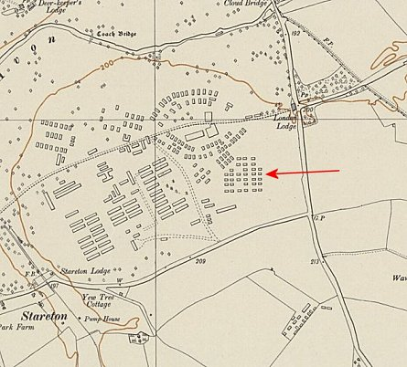
 | Ordnance Survey 1955

Packington Park

Either Camp 667 was located here before/after relocating to Stoneleigh, and/or it was a pow hostel for Stoneleigh. Packington Park (NGR SP 2202 8402) is 17km NW of Stoneleigh, and just 3km SW of Maxstoke Camp 39.

The Pow postcard below was dated 15 Dezember 1946.

Christmas 1946 - The IWM have a copy of a camp magazine stated to be produced at Packington Park. (Ref LBY EJ 437).
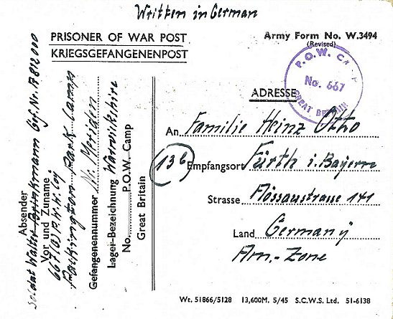 | 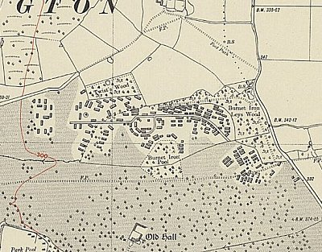
 | Ordnance Survey 1937

WEIHNACHTEN 1946

WEIHNACHTEN 1946

