Camp 666 Stoberry Park, Wells, Somerset

1947 Camp List
666(G.W.Coy) | S | Stoberry Park, Wells, Somerset | Wells 424 | 37(W.O.) | V/1270/4

Prisoner of War Camps (1939 – 1948) - Project report by Roger J.C. Thomas - English Heritage 2003
OS NGR | Sheet | No. | Name & Location | County | Cond’n | Type 1945 | Comments
ST 552 463 | 182 | 666 | Stoberry Park, Wells | Somerset | 4 | German Working Camp | Decorative gate posts & statue of Romulus & Remus.

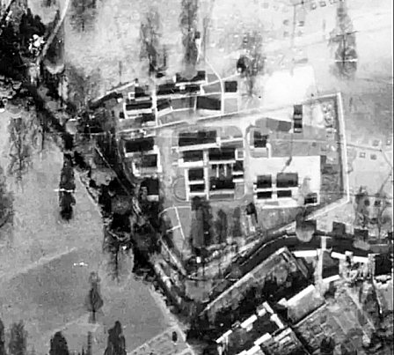  Location: The NGR is for the site shown between College Road and ‘School’ on the map.  1946 aerial photo; Aerial Photo | Historic England  Before the camp:  Pow Camp: Italian, then German POWs  HER - 17552 - Somerset HER  The entrance to the camp had two large stone pillars on College Road.  It is believed that the statue of Romulus and Remus was created by an Italian pow at camp 107 Penleigh, however one article also states that he may have been transferred to Stoberry.  Postal items seen; Pow mail to Italy dated May 1944  April 1945 – Camp list; “German Working Company, 666, W(est), Stoberry Park, Wells.” With a War Establishment code of V/1270/1. | 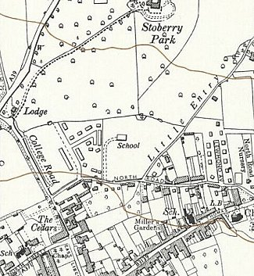
 | Ordnance Survey 1961
September 1945 – Appendix to HQ Southern Command War Diary; “666 Stoberry Park camp, Wells – German working company – capacity 450.”

22 March 1946 – Camp Magazine, No.9; Der Turm : POW Camp 666 - The Wiener Holocaust Library. Article about Stoberry and mention Burnham hostel.

Early 1947 – pows transferred from here to Penleigh Camp 107.

May 1947 – Lecturer’s report for Cross Keys Camp 1022 recorded that Bridgewater and Burnham hostels had been transferred to them.

After the camp:

Further Information:

Hostels

Burnham-On-Sea.

Bridgewater.

