Camp 665 South Littleton, Evesham, Worcestershire

1947 Camp List
665(G.W.Coy) | W | South Littleton, Nr.Evesham, Worcs. (Postal Address) Honeybourne, Evesham, Worestershire | Badsey 357 | 23(W.O.) | V/1270/4

Prisoner of War Camps (1939 – 1948) - Project report by Roger J.C. Thomas - English Heritage 2003
OS NGR | Sheet | No. | Name & Location | County | Cond’n | Type 1945 | Comments
SP 0750 4624 | 150 | 665 | South Littleton, Evesham | Worcestershire | 5 | German Working Camp | Precise location not identified.

NOTE – Camp 665 is given a very close NGR to Camp 277 in the English Heritage Report because this camp was used as a postal address – however, they were separate camps.  Location: Honeybourne area at right of map – South Littleton at upper left. One 1954 OS map shows some buildings around Sheenhill Farm, near centre of map – but not sufficient detail to identify place as the camp.  Before the camp:  Pow Camp:  The use of camps 277 and 665 was questioned in the House of Commons in 1946:  “Mr. De la Bère asked the Minister of Works whether he will indicate the approximate date on which he will be de-requisitioning the Littleton Recreation Ground in Worcestershire; and what steps he is taking with the Ministry of Labour to make some other arrangement for the utilisation of the Honeybourne Camp for the Resettlement Corps.  “Mr. Tomlinson - I regret I cannot say when it will be possible to give up the ​ camp at Littleton, at present occupied by German prisoners of war doing agricultural work. As regards the second part of the Question, Honeybourne Camp is to be occupied for some time to come by members of the Polish Resettlement Corps.” (Hansard, 25 November 1946, Volume 430).  October 1946 – chess matches recorded against this camp, called Honeybourne) in Magazine by Long Marston Camp 6 / 685. | 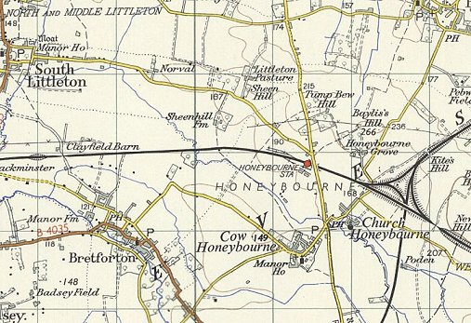
 | Ordnance Survey 1959
By May 1947 – The site had become a pow hostel for Camp 277.

After the camp:

Further Information:

