Camp 661 Eynsham Park, Eynsham, Oxfordshire

Prisoner of War Camps (1939 – 1948) - Project report by Roger J.C. Thomas - English Heritage 2003
OS NGR | Sheet | No. | Name & Location | County | Cond’n | Type 1945 | Comments
SP 395 123 | 164 | 661a | Eynsham Park, Eynsham, North Leigh | Oxfordshire | 5 |  | Site cannot be determined from modern aerial coverage due to tree cover.

Note – a suffix letter (661a) usually denotes a pow hostel. All documents seen do not have this suffix.

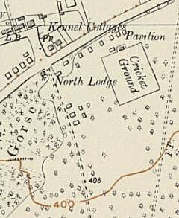  Location: About 4km NE of Witney. The Park is a large area – a 1955 map shows some small buildings along the road and the drive to the Park, but I do not know if these were pow huts.  Before the camp: Large country house and estate. Requisitioned for military.  Pow Camp:  7 May 1945 – PID Progress Report No. 81 – (FO 939/383);  “WORKING COMPANY NO.661  D.P.W. have now decided that this Working Company which is to be formed on the 16th May at Eynsham park, Oxford will contain all ‘blacks’. The population of this Company will be 425 Ps/W and these will be drawn by D.P.W. from base camps.”  Blacks = Political category C, Nazis.  Spring 1945 – Camp list; “German Working Company, 661, S(outh), Eynsham Park camp, Eynsham, Oxford.” With a War Establishment code V/1270/1.  September 1945 - Appendix to HQ Southern Command War Diary; 661 Eynsham Park camp, Oxford – German working company – capacity 450. | 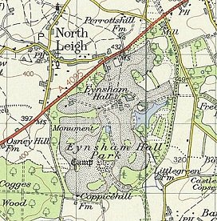
 | Ordnance Survey 1960

May 1946 – Camp magazine No.5; Unsere Stimme : G.P.o.W.W.Coy 661; Eynsham Park camp - The Wiener Holocaust Library

After the camp:

Further Information:

‘Prisoners of England’ by Miriam Kochan has four plates for the camp – a drawing and three photographs.

Archives and Cornish Studies Service have copies of the Camp magazine dated 1946 – Ref ST/503

London Metropolitan Archives have copies of the camp magazine, numbers 5,9-10,13-15,19-20,22-23 – dated 1946 to 1947. Reference LMA/4288/D/04/011

