Camp 658 Hill Camp, Westbury, Wiltshire

1947 Camp List
658(G.W.Coy) | S | Hill Camp, Westbury, Wilts | Westbury(Wilts) 273 Ext.12 | 80(W.O.) | V/1270/4

Prisoner of War Camps (1939 – 1948) - Project report by Roger J.C. Thomas - English Heritage 2003
OS NGR | Sheet | No. | Name & Location | County | Cond’n | Type 1945 | Comments
ST 8726 5111 | 183 | 658 | Hill Camp, Westbury | Wiltshire | 5 | German Working Camp | Precise location not identified, NGR given for centre of Westbury.

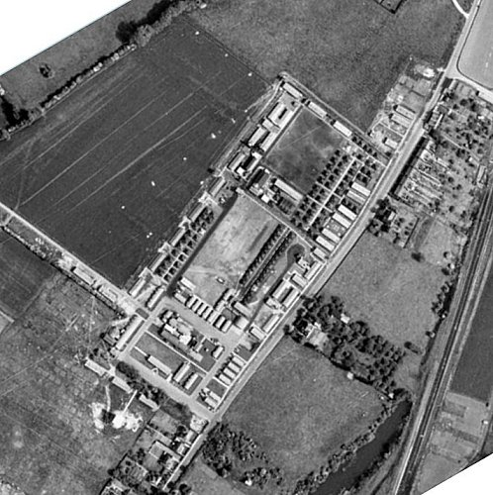  Location: Hill Camp was on Ham Road in Westbury, NGR ST 864 525 with the entrance on Ham Road.  1945 aerial photo - Aerial Photo | Historic England  Camp 114 Eden Vale was near this site, just over 2 km to the S.  Before the camp: Farmland. Military camp, including US forces.  Pow Camp: Italian and then German pows.  My thanks go to David Jenkins who provided the location for the camp and the following information – “After speaking to several elderly residents who were alive at the time, they told me that the camp had both Italians and Germans in. I’m not sure if it was at one time only the Military did move POW’s around. My view is that the camp had Italians first and then Germans, both of which helped contribute towards local labour i.e. working on farms and repairing roads etc.  With regards to the date the camp was open I’m not exactly sure. It may of been 1943/44 but the date of closure would be 1947.” | 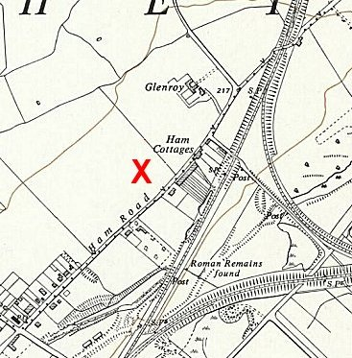
 | Ordnance Survey 1961

Oversight and development of re-education activities and English teaching for German pows was carried out by PID (Political Intelligence Department of the Foreign Office) / COGA (Control Office for Germany and Austria – UK). Visits and reports were made. The standard of the reports varied greatly. The visitors took little interest, if any, in activities other than re-education. They rarely mentioned welfare, sports, games, pastimes, crafts, etc of the pows. If there were still Italian pows in hostels, they were usually ignored by PID.

December 1945 – a brief review of the camp was made, referred to in a later report.

Spring 1946 – 100 pows from camps in the US. Most had very low morale as they had been misinformed in the US that they were being repatriated. Instead, they found themselves in working camps in the UK. 50 Pows from Canada, these were often C grade; they had been captured early in the war and retained their Nazi ideology. 50 pows transferred from camps in Belgium where they had experienced extremely poor conditions.
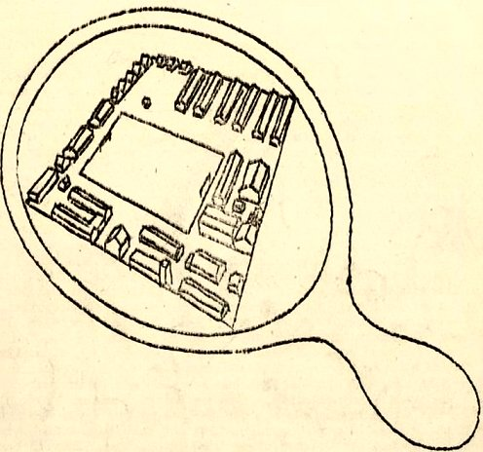
20 April 1946 – Camp magazine No.3; Lagerspiegel : Zeitung des P.W. Camps 658 in Westbury (Engl.) - The Wiener Holocaust Library

Front page illustration for the magazine, showing a plan of the camp >

27 May 1946 – English Inspector’s Report. Total strength 576 in huts.

55 pupils in 3 classes. Lessons carried out in the dining hut.

29 May to 2 June 1946 – Report mainly on political screening. Strength; 576. Some were on detachment at Le Marchant Camp 410, but number or purpose was not given.

Commandant: Major H S Armstrong Camp leader: O/Fw Gerh. Tobergte (A).
Adjutant: Capt Baker (being demobilised). German M/O: Ass.Arzt Gerh Hirtschulz (B). “No
Party record. Sound type.”

Commandant Armstrong was supportive of re-education and was well regarded by the pows.

The camp leader was a professional soldier, “but not militaristic.” Well liked by all, “very conscientious.”

Political screening: | A+ | A | A- | B+ | B | B- | C | C+ | Unknown
 | 2 | 40 | - | 121 | 244 | 145 | 22 | 1 | 1

It was stated that about 70% of the pows were ‘youth’ (under 25) – this is extremely high in comparison to other camps and must be questioned as the next report, just a month later, put the figure at about 30%.

Resentment was caused when letters from home spoke of Nazi party members going back to their old jobs. Pows from the Russian and Polish zones were receiving little, if any, post.

Protestant padre; Gefr Karl Fassold (A). “A fine type… fought against the Nationalsoz [Nazi party]… he was watched by the Gestapo.”

A summary of re-education activities was given; there was a camp magazine and a library with 606 books. There was a recreation room with British newspapers and a wall news-sheet. Discussion groups were held.

Education classes were held for arts, signwriting, singing, English, technical drawing, and book-keeping

15-16 July 1946 – General Survey and Interview candidates for special training course at Wilton Hall. Strength; 1 officer (the M.O.), 576 Other Ranks, including 43 detached to Le Marchant Camp 410.

Commandant: Major H S Armstrong Camp leader: O/Fw Gerh. Tobergte (A).
Interpreter: None Deputy C/L: Gef Nies (A+)
German M/O: Ass.Arzt Gerh Hirtschulz (B).

Political screening: | A+ | A | A- | B+ | B | B- | C | C+ | Unknown
 | 2 | 40 | - | 121 | 244 | 145 | 22 | 1 | 1

High morale was noted due to:
- Excellent Commandant and good treatment.
- Start of repatriation
- Good camp staff
- Good range of activities.
The main negative factors were:
- Bad news from the Russian zone.
- Lack of news from the Polish zone.
- Reference to Nazis taking jobs in Germany.
- Restricted mail facilities for the pows.
- Barbed wire around the camp.
- Poor pay.

30% of the pows were ‘youth.’ This is in-line with other camps. They were not regarded as a problem and occasional discussion groups were held for them.

There were 2 pow leaders for re-education activities. The standard list was given:

Wochenpost and Ausblick – 80 and 40 copies respectively. More requested.

Newspapers – “Adequate.” About 30 British papers received. 15 German papers sent by PID each month. No Swiss papers.

Library – 606 books + 200 American books left by the US forces previously based at this site.

Lectures – Regular with 250 to 300 attending. More requested.

Discussion groups – Regular, about 160 to 180 attended.

Films – Supplied by YMCA every 3 weeks (entertainment), and by PID fortnightly (documentaries).

Camp magazine – 14 pages, weekly.

Wireless – 5 sets and 14 loudspeakers left behind by the US troops.

Press review – a daily news-sheet issued.

Other camp activities –

Religion – About 300 Protestants and 250 RC. Popular Padre Fassold held weekly services in Westbury Church – also attended by pows from Eden Vale Camp 114. A local priest gave RC mass and there was a fortnightly study hour.

Education – French (15 pupils), music, arts, sign-writing, technical drawing, bookkeeping, maths.

Entertainment – A theatre available and a group was starting up. A 9-member band played dance music in and outside the camp. Gramophone music concerts were given. There was a 32-member choir giving monthly concerts.

20 November 1946 – English Inspector’s Report. Strength; 469.

Commandant: Major Armstrong Camp leader: G/F K H Chille

29 pupils in 2 classes.

31 December 1946 – 2 January 1947 – Report on Re-education and Screening. Strength; 1 officer, 495 O.R.

Commandant: Major H S Armstrong Camp leader: Fw Oziepka (B)
Interpreter: Sgt Jessen Deputy C/L: -
German M/O: Dr Drees

The Interpreter was Danish, he was not involved in re-education activities.
Camp leader Oziepka had only recently taken up the post. The previous leader, Chille, resigned due to ill health, but still worked as an interpreter.

Political screening: | A | B+ | B | B- | C
 | 14 | 100 | 227 | 141 | 14

25 pows had appealed against their political grades; the better the grade, the sooner repatriated, in theory. 22 of the appeals were successful. A further 35 were appealing. 65 pows repatriated to date.

This is a very confusing report as it often conflicts with previous comments. The atmosphere within the camp was recorded in very negative ways, reversing previous comments. But, there are also some aspects which do not make sense, especially the list of re-education activities below.

Morale, previously recorded as high, was; “Very low indeed. The depression and apathy in this camp are so marked that even Xmas was entirely ignored.” The main reasons given were slow repatriation and bad news from Germany. However, other camps suffered the same issues, and though many had low morale it did not go as far as ignoring Christmas! Other comments showed additional negative aspects not described before;

“The attitude of the British staff is criticised for its lack of understanding and help.
Only 10% of the men were allowed out at Xmas, but this rule has now been changed and everybody can leave camp.
After one or two Ps.W were recently found outside the barbed wire in the evenings, the Commandant ordered more and higher wire to be put up.
Entertainment and educational activities are practically non-existent.”

The restriction on leaving camp did not apply in the majority of other camps – especially at Christmas. Many camps had removed or drastically reduced barbed wire. The comment on lack of activities was a reversal of previous comments. The two leaders of re-education activities had been repatriated, but that does not fully explain how activities had become, “practically non-existent.”

Nearly 50% were ‘youth;’ a comment regarding them indicated issues not previously revealed - “A good many of them are anxious to learn but have no opportunity. The older men discourage them.” Why, and in what way, were they discouraged?

The standard list of re-education activities was given. It began with the statement; “The general re-education picture is dark. Re-educational activities have almost completely ceased for the time being.” But, the list shows a very similar picture as in many other camps and does not fit the description, “almost completely ceased.” Only two activities were recorded as having ceased, and one of those, ‘Press review,’ was for a reason outside of the pows’ control.

Wochenpost and Ausblick – separate appendix.

Newspapers – Same as before; British papers purchased, some German sent, no Swiss.

Library – 640 books.

Lectures – Still regular; approximately 1 per fortnight.

Discussion groups – Ceased, hoped to restart.

Films – Still regularly shown; “All English films met with great interest.”

Camp magazine – Increased to 20 pages fortnightly. Paper and stencils in short supply, as everywhere else.

Wireless – “Satisfactory.”

Press review – the daily news-sheet ceased due to lack of stencils being sent to them by COGA, would start again as soon as stencils arrived.

Information room – A display of text and pictures on agriculture had been sent by COGA and displayed. It was of little interest, but no further materials had been sent.

Other camp activities –

Religion – arrangements as before

Education – Classes for shorthand, French, and Russian.

Entertainments – No theatre group. Players in the orchestra had been repatriated; it was hoped to form a new band.

There was a later comment that the Commandant was absent as he was temporarily i/c of a Pioneer Corps Group and that this, “has been detrimental to his camp.” Perhaps this explains the reported fall in standards?

April 1947 – Protestant Padre, Fassold, was transferred to camp 114. It is likely the camp closed around this time.

Known Commandants:
Major H S Armstrong. Later Commandant at Horbling Camp 80.

After the camp: 2020 residential estate.

Further Information:

National Archives – FO 939/186 – 658 Working Camp, Hill Camp, Westbury, Wiltshire. Dated 1945 – 1947. Used above.

