Camp 652 & 693 Durnell’s Farm Camp & Magazine Camp, Didcot, Berkshire

1947 Camp List
652(G.W.Coy) | S | Magazine Camp, Didcot, Berks | Didcot 2191 Ext.172/3 | 52(W.O.) | V/1456/2
693(G.W.Coy) | S | Durnalls Farm Camp, Didcot, Berks | Didcot 2191 Ext.130 | 52(W.O.) | V/1456/2

Prisoner of War Camps (1939 – 1948) - Project report by Roger J.C. Thomas - English Heritage 2003
OS NGR | Sheet | No. | Name & Location | County | Cond’n | Type 1945 | Comments
SU 5136 9182 | 174 | 652 | Durnell's Farm Camp (Magazine Camp),  Central Ordnance Depot, Didcot | Berkshire | 4 |  | Site occupied by Didcot power station.  See Camp no.652/693.
SU 5136 9182 | 174 | 693 |  | Berkshire | 4 | German working company | Site occupied by Didcot power station.  See Camp no.652/693.

Location: Camp 652 and 693 were 2 separate camps within the huge Didcot COD area. I believe that these were the locations of the 2 sites:  Magazine Barracks, Camp 652, site B - was bounded by Brickhill, Umgeni, Argyle, and Somtseu Roads, but those roads disappeared when the site was redeveloped.  Durnell’s Farm Site, Camp 693, shown on Map at A. In 1934 the Farm was located at the tip of the arrow, but then became part of the large COD site.  Before the camp: Aerial photos from the 1940’s showing many huts over a wide area - Aerial Photo | Historic England  Pow Camp: German pow camps.  1945 – A pow stated that Italians had been located here previously, (not confirmed). He recalled large marquee type tents with 30 men in each  Alf Eiserbeck, a pow at the camp gave an account of life there. Part of this concerned the work carried out by pows in their spare time; “The camp itself was like a workshop. Everyone worked like mad, making toys. It was like a factory. They were then sold for cigarettes. The most impossible things were made there: dachshunds on wheels, with rubber in the middle so that when they were pulled along they wiggled; chickens on wooden boards who pecked when elastic was pulled. We also made suitcases out of plywood. We took tools from the depot. One tent even had a complete dentist’s outfit, which it used for engraving. Unfortunately, this was missed and had to be returned.” (Prisoners of England – Miriam Kochan – 1980 – MacMillan).  September 1945 - Appendix to HQ Southern Command War Diary; “652 Magazine camp, COD Didcot – German working company – capacity 1000.”  1946 – Intake of many pows from camps in the USA. Most had a very low morale as they had been misinformed in the US they were being repatriated. Instead, they found themselves in working camps in the UK.  1946 – month? Two pows escaped and got to Dover Docks. They were returned to the camp and suffered 21 days confinement. | 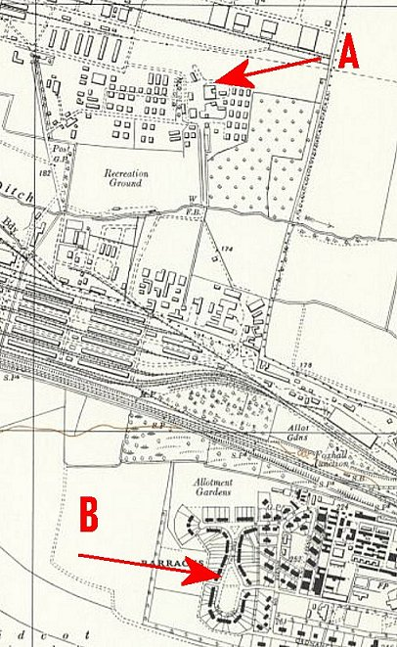
 | Ordnance Survey 1960
5 May 1946 – Camp Magazine for 652, No.2; Der Spiegel : Lagerzeitung des P.o.W. Camps 652 - The Wiener Holocaust Library

1 June 1946 – Camp magazine for 693, No.1; Rundschau : Lagerzeitung des Deutsche Kriegsgefangenenlagers 693 Durnells Farm Camp Didcot, Berks - The Wiener Holocaust Library

Camp leader; Ferdinand Jedermann

Oversight and development of re-education activities and English teaching for German pows was carried out by PID (Political Intelligence Department of the Foreign Office) / COGA (Control Office for Germany and Austria – UK). Visits and reports were made. The standard of the reports varied greatly. The visitors took little interest, if any, in activities other than re-education. They rarely mentioned welfare, sports, games, pastimes, crafts, etc of the pows. If there were still Italian pows in hostels, they were usually ignored by PID.

14 – 17 August 1946 – Camp 693 (Durnells Farm) Didcot. Visit by 4 members of the Segregation Section, mainly for political screening. Strength; 0 officers, 1020 Other Ranks.

Commandant: Major N Loans Camp Leader: Friedrich Jadzinski (A)
Interpreter: Sgt Breslauer Deputy C/L: Matthias Ziegler (B+)

The camp leader was in an acting position as the full leader (Ferdinand Jedermann B+) was on a course at Wilton Park. Aged 32, a regular soldier, “unimpressive but honest.” He had been a pow in the USA.

Deputy Ziegler, aged 27, mechanic; “Likeable, but politically not fully developed.”

Political screening: | A+ | A | A- | B+ | B | B- | C | C+ | Unknown
 | 2 | 128 | - | 299 | 414 | 144 | 29 | 2 | 2

A high number of ‘A’s’ compared to most camps. Despite this, the visitors considered the pows to be apathetic towards politics and not making sufficient progress. There was little attempt to develop re-education activities.

The pows formed a political working group to develop activities, however this ceased when the leaders were repatriated at the end of 1946.

End of 1946 - A German pow committed suicide by hanging.

19 – 22 February 1947 – Camp 693 Durnells Farm Camp. Re-education visit. Strength 0 officers, 699 O.R. Listed as the 3rd visit, so at least 1 report is missing from the file.

Commandant: (Acting) Captain G E S Williams Camp Leader: Uffz Hans Bornemann (B+)
Interpreter: Sgt A Scheinemann Deputy C/L: Fw Herbert Modlich (C)
German M/O: Oberarzt Dieter Mueller (B) – based at 652.

The Commandant, Major Bryan, was on leave.

The Interpreter was from 652 company, but acted as Interpreter for both sites.

Camp Leader Bornemann had been a clerk and a member of the Nazi Party. Newly elected as leader, he had been magazine editor and also taught English and French. “Intelligent, keen and active.”

The Deputy had been a member of the Nazi party. Newly elected; “Anxious to do his new job well and to live down his C grading.”

Elections for the 2 leaders were by secret ballot with voting booths etc. to give a taste of democracy.

Political screening: | A | B_+ | B | B- | C | C+
 | 2 | 214 | 319 | 111 | 32 | 2

59 pows were appealing against their political grades – the better the grade, the sooner repatriated, in theory.

265 pows had been repatriated to date = 100 white (A grade), 75 sick, others due to demand for particular skills made by COGA in Germany.

Morale was recorded as good. Positive factors were good entertainment and sports, and the Commandant was very popular. The main negative factor was always slow repatriation.

About 30% of the pows were ‘youth’ (under 25), they were not seen as a problem.

The standard list of re-education activities was given:

Wochenpost and Ausblick – separate appendix.

Newspapers – British and foreign papers; “Adequate.” Swiss papers to be ordered.

Library – “Adequate.”

Lectures – only 1 since Christmas 1946.

Discussion group – Hoped to start.

Films – “Adequate.”

Wireless – Programmes and press reviews broadcast by loudspeakers throughout the camp.

Camp magazine – Issued.

Press review – broadcast, + occasional news sheet for ‘special’ news.

English Instruction – Separate appendix.

Information room – Started, first exhibition of text and pictures was entitled ‘Youth.’

After the camp: Magazine barracks were used as emergency housing. Later the whole site became Didcot Power Station.

Further Information:

National Archives – FO 1120/246 – Re-educational survey visit reports for camps 685 to 708 – dated 1946-1948. 2 reports used above.

IWM have a copy of the Camp 693 newspaper from January 1947 – Catalogue LBY E.J.414. The German Federal Archives also have a copy – date unknown.

A copy of a newspaper from Camp 652 in 1946 is held by the London Metropolitan Archives – Reference LMA/4288/D/04/009

