Camp 649 Swindon Hill Camp, Swindon, Cheltenham, Gloucestershire

ICRC – Labour Camp. 649. Swindon Hill Camp, Swindon, Cheltenham, Glos.

Location: Not sure if the listing above should read Swindon Hall?  Swindon village is just to the N of Cheltenham. The Hall and estate, the manor and Manor Farm were all requisitioned for military use. Aerial photograph from 1946 shows the main cluster of huts at NGR SO 935 247, (X on map).  Before the camp: Swindon Hall and estate were requisitioned for military use at the start of the war. Nissen huts were built in the grounds to accommodate various British units.  Pow Camp: Italian co-operator pows guarded by the Pioneer Corps.  December 1944 - Camp opened.  January 1945 – Camp list; “Add – 3 new Italian Working Companies… 649, S(outh), Swindon Hill Camp, Swindon Village, Nr Cheltenham.” [+648 and 650].  Believed to have been open for a short time, probably just a few months.  After the camp:  Further Information: | 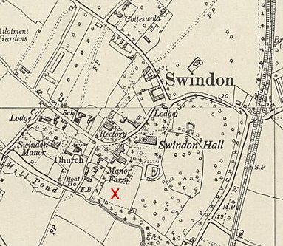
 | Ordnance Survey 1954

