Camp 648 King Harry Ferry Camp / Pencalenick, Trelissick, Truro, Devon

ICRC – Labour Camp. 648. King Harry Ferry Camp, Trilissik, Nr Feoch, Truro, Cornwall.

Location: 2 sites recorded for 648~:  - King Harry Ferry, Approximate NGR of W side; SW 840 396.  - Pencalenick House, SW 857 452.  Pencalenick is about 3 miles N of King Harry, (about 6½ miles by road).  Before the camp: There were many US camps in and around Truro, including at Trelissick House and Gardens and at Pencalenick House.  Pencalenick House was requisitioned by the War Office and served various military functions, including a training base, an army field hospital, a staging site for the D-Day landings, and a prisoner-of-war camp.  Pow Camp: Italian labour camp (s?).  Which site came first? The ICRC list was issued at the end of 1944 / beginning of 1945, so that would put King Harry first. BUT, it is also possible that both sites were used at the same time. | 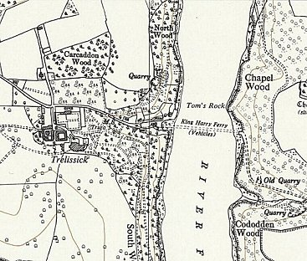 | 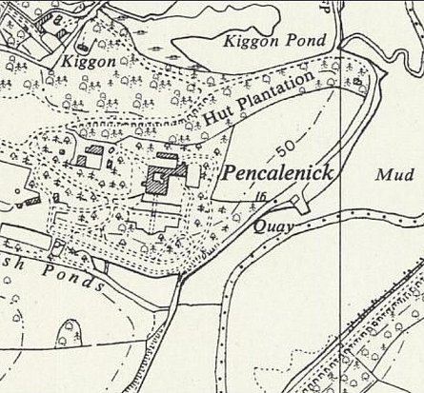
 | King Harry, Ordnance Survey 1962 | Pencalenick, Ordnance Survey 1962
January 1945 – Camp list; “Add – 3 new Italian Working Companies…. 648 S(outh) Pencalenick House, Pencalenick, Nr Truro, Cornwall…..” [+ 649 and 650]

September 1945 - Appendix to HQ Southern Command War Diary; “648 Pencalenick House, Truro – Italian working company – capacity 300.”

After the camp: Pencalenick was left ruinous and was bought by Cornwall Council in 1948.

Further Information:

