Camp 645 Quarr House, Sway, Lymington, Hampshire

Prisoner of War Camps (1939 – 1948) - Project report by Roger J.C. Thomas - English Heritage 2003
OS NGR | Sheet | No. | Name & Location | County | Cond’n | Type 1945 | Comments
SZ 2757 9787 | 195 | 645 | Quarr House, Sway, Lymington | Hampshire | 5 |  | Precise location not identified, NGRcgiven for centre of Sway.

Location: The location above is shown at ‘A’ on the map. Though there are some buildings, I think these may be part of what is marked on modern OS maps as Clayton Farm.  Quarr House is 1.5km to the N at NGR SZ 2752 9931  Before the camp: Reports that a Canadian tank regiment were stationed at Quarr House and nearby Sway Place.  Pow Camp: Italian pows  Early 1945 – Camp List; “Italian Working Company, 645, S(outh), Quarr House, Sway, Lymington.”  After the camp: Quarr House was divided up into flats.  Further Information: | 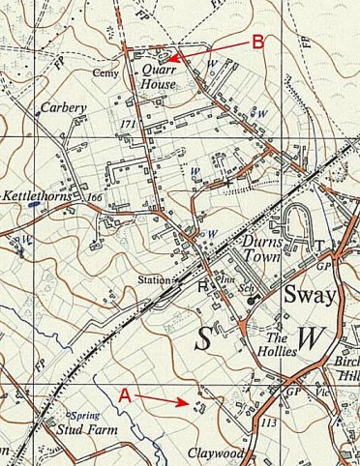
 | Ordnance Survey 1961

