Camp 624 / 1022 Shiphay Hutments, Torquay, Devon

Included in the 1945 ICRC Camp List – Labour Camp. 624. Shiphay Hutments, Torquay, Devon.

Location: Shiphay is a district in the north of Torquay. The location of the camp was identified in ‘Shiphay At War’ by Roger Hill (Xlibris, 2006) as being in open fields between Shiphay Avenue and Shiphay Lane. NGR for the centre of the fields SX 895 654.  Before the camp: The huts were used by the Prudential before moving back to London in 1943. The site was then used as the base for the US 237th and 238th Engineering Battalion within D-Day Marshalling Area Camp K3.  Pow Camp: Italian labour camp.  September 1945 - Appendix to HQ Southern Command War Diary; “624 Shiphay Hutments, Torquay – Italian working company – capacity 300.”  4 August 1946 – Report on German Working Company No.1022, Shiphay, Torquay.  Strength; 0 officers, 441 Other Ranks, including; 106 at Bradninch / 170 at Plymouth. | 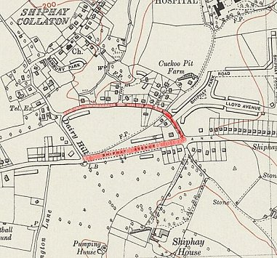
  Oversight and development of re-education activities and English teaching for German pows was carried out by PID (Political Intelligence Department of the Foreign Office) / COGA (Control Office for Germany and Austria – UK). Visits and reports were made. The standard of the reports varied greatly. The visitors took little interest, if any, in activities other than re-education. They rarely mentioned welfare, sports, games, pastimes, crafts, etc of the pows. If there were still Italian pows in hostels, they were usually ignored by PID.
 | Ordnance Survey 1938
Commandant: Major H Gough Camp leader: Uffz Spehr (A)
Interpreter: None Deputy C/L: H/Fw Sesterhenn (B+)
German M.O.: None.
Political screening had not been carried out.

The first German pows arrived from camps in the USA, three weeks earlier. The pow staff were appointed by the Commandant.

Morale was recorded; “on the whole is good”. This is surprising as other camps recorded low morale from pows shipped from the US where they had been misinformed that they were being repatriated. Morale was expected to improve as activities developed within the camp.

c.100 pows were ‘youth’ (under 25). They were not regarded as a problem.

The standard list of re-educational activities was given, and showed the lack of development;

Wochenpost and Ausblick – None received.

Newspapers – None. Local shortage also made purchasing papers difficult.

Library / Lectures / Films – None.

Wireless – Good; able to receive Hamburg station. Controlled from the camp leader’s office.

English Instruction – 50 beginners, 20 advanced. No texts or dictionaries available.

Other camp activities –

Religion – pows able to visit a church in Shiphay.

Entertainment – No theatre group or orchestra.

Summer / Autumn 1946 – Brief reports for Shiphay Camp 1022 on lectures held at HQ and 2 hostels at Bradninch and Plymouth.

December 1946 – Lecturer’s report recorded that HQ was based at Bradninch, and Shiphay had become a pow hostel. There was another hostel at Cross Keys, Taunton.

After the camp:

Further Information:

National Archives – FO 939/328, used above.

Hostels –

Bradninch

4/8/46 – 106 pows. Leader; Krumbach (C+); due to return to HQ and be replaced by the deputy, Leis. No re-education activities – had its own wireless.

Protestant pows able to attend a church at Cullompton.

Late 1946 – became the HQ for Camp 1022

Plymouth

4/8/46 – 170 pows. Leader; O/Fw Peter Boemler (B+).

15 copies of Wochenpost had been received. There were 2 English classes, 1 beginners, 1 advanced. No teaching materials.

Religious services were held in the camp. A Benedictine monk from Plymouth visited the RC.

September 1946 – reports of an arts and crafts exhibition held at the hostel that was very high quality.

