Camp 641 Earls Cross House Camp, Dornoch, Sutherland

Prisoner of War Camps (1939 – 1948) - Project report by Roger J.C. Thomas - English Heritage 2003
OS NGR | Sheet | No. | Name & Location | County | Cond’n | Type 1945 | Comments
 |  | 641 | Earls Cross House Camp, Dornoch | Sutherland |  |  | Scotland

Location: NGR NH 8036 9023  Before the camp:  Pow Camp: The Buildings At Risk Register for Scotland states that the nearby house was used to house Italian pows. However, Canmore only records a German working camp in the nearby grounds.  Canmore – ‘immediately E of Earl’s Cross House’…. on air photographs – ‘Visible are at least seven or eight huts’.  Early 1945 – Camp list; “Italian Working Company, 641, Sc, Earls Cross House camp, Dornoch, Sutherland.”  After the camp: Renamed Ambassador House.  Further Information:  http://canmore.org.uk/site/272676  Air photographs - 106G/Scot/UK 114, 4149-4150, flown 23 May 1946 | 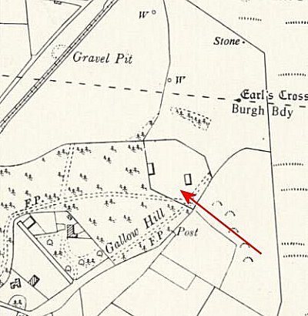
 | Ordnance Survey 1960

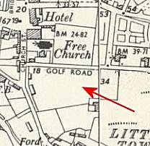 | The Canmore site states that this camp may be linked to one identified in Dornoch at Golf Road which is less than 1 km away - NGR NH 7997 8951.  “A small possible military camp has been identified from vertical air photographs (106G/Scot/UK 114, 4150-4151, flown 23 May 1946), in an open area bounded by Church Street, Golf Road and Sunnybank. Set around the edge of the area are at least 22 huts. The camp may be connected with the German Working prisoner-of-war Camp found at Earl's Cross House or with military activity at Dornoch Airfield.  Nothing survives of this camp as the site has now been built over by several houses including Dune House, Wuppertal and Clunie Crescent.”  http://canmore.org.uk/event/652411

