Camp 640 St Andrew's Hall, Kirkcudbright, Kirkcudbrightshire (+ Mansecroft / Twynholm)

Prisoner of War Camps (1939 – 1948) - Project report by Roger J.C. Thomas - English Heritage 2003
OS NGR | Sheet | No. | Name & Location | County | Cond’n | Type 1945 | Comments
 |  | 640 | St Andrew's Hall, St Mary's Isle, Kirkudbright | Kirkudbrightshire |  |  | Scotland

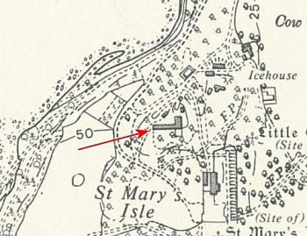  Location: There is no record of a St Andrew’s Hall on St Mary’s Isle. There is a St Andrew’s Hall on the High Street at nearby Kirkcudbright.  The ‘Secret Scotland’ website stated there is no record of that building ever being used to billet PoWs. The same website lists the Isle House Stables (NGR NX 6742 4942 shown on map at left) being used for a while to house low-risk Italian internees at the start of the war.  Pow Camp: From the location details above and comments below, I believe that St Andrew’s Hall in Kirkcudbright was used as the mailing address and administration centre for various small sites located on St Mary’s Isle and the local area. A small number of staff-pows may have been accommodated in the Hall.  There are memories of Italians being held at the camp, not of Germans – probably after the Italian internees.  The Kirkcudbright History Society put out an information request and received several replies, (web address below).  David Mitchell reported that the pows on St Mary’s Isle; “were housed in all the houses down there plus what was left of the mansion. There were several Nissen huts built in Laundry Cottage garden and elsewhere. They were not locked in and went to work at various farms in the area. At Christmas they built a magnificent nativity scene which the townspeople went down to see as it was so spectacular.”  John Clarke – “I lived in the Gardener’s Cottage in 1945. I remember Italian Prisoners being there. I used to gather Spanish Chestnuts and they gave me chocolate in exchange. I seem to remember that in the woods opposite the Cottages there were | 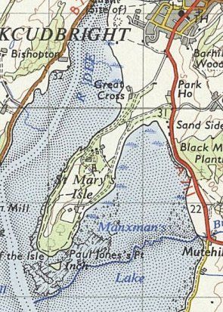
 | Ordnance Survey 1955
some buildings and I think that was where they were. That was somewhere between the cottages and the remains of the ‘big house’.”

Jackie King – “We live in what was the servant’s quarters of the original mansion house in St Marys Isle, originally attached to the main house. It was a ruin when my husband bought it and when we decided to renovate we found lots of Italian writing on the walls in the outhouse which had been the toilet block. This had been written by Italian POWs. Sadly, none of this remains because the house was subsequently renovated….no digital cameras in those days.”

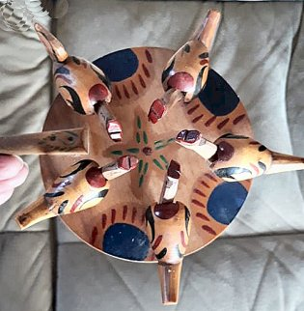 | Mary Cummings – “I lived at Laundry Cottage and was told there was a camp in the garden. There was a raised area in the centre which were the foundations of a building or Nissen hut.”  Felicity Pope – “Not relevant to the Isle but there were Italian PoWs in the Hall behind 81/83 High St. Used to give my Granny toothpaste in exchange for a bath I think my Mother said.”  Bill Smith – “Remember prisoners used to make toys for local kids. I remember I had one made from a table tennis bat. It had model chickens around connected by string to a weight underneath and when you moved it slowly around it looked like chickens were feeding.”  Babs Mitchell – “Wow - I still have one of those tucked away somewhere safe. I wonder if that is what you are describing.”  < Bab’s toy. This is similar to others made by pows and held in various museums.
Early 1945 – Camp list; “Italian Working Company, 640, St Andrews Hall, St.Mary’s isle, Kircudbright.”

Conclusion and further research by the History Society – ‘There definitely seems to have been a camp down the Isle with more Italians living in the town. Reference is made to them being in the Hall behind 81/83 High St which was part of St Andrews Hall. We would, however, be very interested in finding out anywhere else in the town where they might have been living.’

[With grateful thanks to Helen Bowick of the History Society].

After the camp:

Further Information:

www.kirkcudbrighthistorysociety.org.uk/

Hostel  Mansecroft / Twynholm. NGR NX 668 542  1943 / 1944 – recorded as a hostel for Holm Park Camp 113.  Air photographs show at least 7 huts, probably Nissen inside a rectangular perimeter fence.  Leo McClymont, interviewed for The Daily Record in April 2020 recalled – “Italian prisoners of war came from a camp near Twynholm,” he said. “They worked for the Forestry Commission in the woods and came in a truck with a British driver. “It was supposed he had a rifle but he read the paper and slept all day. The prisoners would have to wake him up to get back to their camp.”  After the camp: Secret Scotland records Polish refugees at the site. Agricultural Hostel. 2020 housing on site.  Further Information:  Canmore - http://canmore.org.uk/site/294647  RAF vertical air photographs - 106G/UK42 421, frames 4033-4034, flown 19 June 1945 | 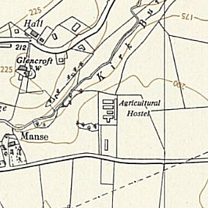
 | Ordnance Survey 1957

