Camp 640 Dodds Camp, Caister, Norfolk

Included in the 1945 ICRC Camp List – Labour Camp. 640. Dodds Camp, Caister, Norfolk.

Location: NGR TG 5190 1328. Dodd’s Camp became known as Caister Holiday Camp.  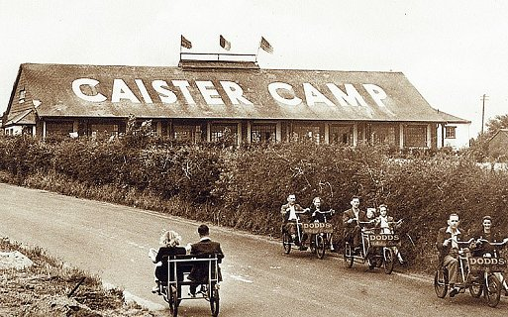  Before the camp: The oldest holiday park in the country. Fletcher Dodd made a small camp for his socialist friends to stay in his garden at Hill House. He expanded this with huts and tents across the road from his house to become a ‘socialist holiday camp’. The camp was requisitioned at the start of the war. Used for a while as a training and transit camp for the military.  <Postcard showing pre-war holiday camp.  Pow Camp: Italian pows. Tents and the holiday huts were used.  Local history states; “The buildings on the west side of the camp were used to house Italian prisoners of war and men from the 2nd Battalion the Sherwood Foresters were billeted in the chalets on the east side of the camp.” https://caisterparishcouncil.gov.uk/history-of-the-village/  The holiday camp is recorded as having re-opened in 1946.  After the camp: Reverted to a holiday camp. 2020 a Haven holiday camp.  Further Information: | 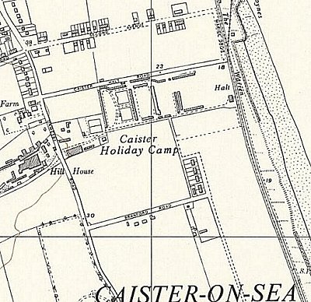
 | Ordnance Survey 1957

