Camp 638 (& 674) Stratton Factory Camp, Swindon, Wiltshire

Included in the 1945 ICRC Camp List – Labour Camp. 638. Kingsdown Hutted camp, Stratton, Swindon, Wilts.

1947 Camp List
674(G.W.Coy) | S | Stratton Factory Camp, Swindon, Wilts | Swindon 3681 Ext.63 | 80(W.O.) | V/1270/4

Prisoner of War Camps (1939 – 1948) - Project report by Roger J.C. Thomas - English Heritage 2003
OS NGR | Sheet | No. | Name & Location | County | Cond’n | Type 1945 | Comments
SU 1703 8720 | 173 | 638 | Stratton Factory Camp, Swindon | Wiltshire | 5 | German Working Company | Precise location not identified. NGR for centre of Stratton St Margaret. See Camp no.638/674.

Location: The camp relocated within Swindon. Listed locations –  1945 ICRC list – Kingsdown Hutted camp, Stratton, Swindon, Wilts; just to the N of the map.  September 1945 – Lawns Camp, Old Town, Swindon. The Lawns area is about 2 miles S of the map.  1947 list - Stratton Factory Camp; Powder Works, Stratton. NGR SU 164 864.  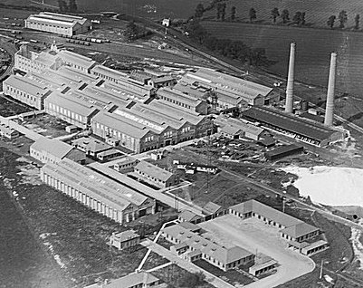  Before the camp: 1947 large factory site built during WW1. Site used by the Pioneer Corps before it became a pow camp.  <Pre-war picture. The two chimneys were demolished at the start of the war as they could have been used for German pilots to navigate.  Pow Camp: Italian and then German pows.  The parish history records the pow camp at the Stratton powder factory site; “a pow camp housing first Cypriots then Germans”. (No response regarding Cypriots).  September 1945 - Appendix to HQ Southern Command War Diary; “638 Lawns Camp, Old Town, Swindon – Italian working company – capacity 300.”  25 May 1946 – Camp Magazine for 674, Stratton Factory Camp, No.1; Der Zuspruch : Lagerzeitchrift des Camp 674 - The Wiener Holocaust Library  January 1948 – listed as a hostel for Lodge Farm Camp 28 with 190 pows. (See Camp 25).  After the camp: 2020 area is Kembrey Park Industrial Trading Estate.  Further Information: | 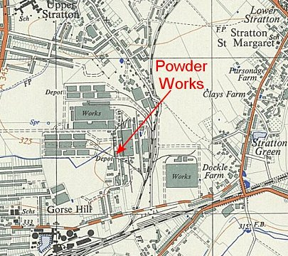
 | Ordnance Survey 1959

