Camp 636 (& 691) Cowick Hall, Snaith, Yorkshire

Included in the 1945 ICRC Camp List – Labour Camp. 636. Cowick Hall, Snaith, Goole, Yorks.

Prisoner of War Camps (1939 – 1948) - Project report by Roger J.C. Thomas - English Heritage 2003
OS NGR | Sheet | No. | Name & Location | County | Cond’n | Type 1945 | Comments
SE 6555 2120 | 105 | 636 | Cowick Hall, West Cowick, Snaith | Yorkshire | 4 |  | Restored parkland. See Camp no.636/691.
SE 6555 2120 | 105 | 691 | Cowick Hall, West Cowick, Snaith | Yorkshire | 4 | German working company | Restored parkland. See Camp no.636/691.

Location: Camp shown on map to W of Hall and along the drive.  Before the camp: Country house and estate. The Hall was largely derelict at the start of the war.  Pow Camp: Italian and then German pows.  Early 1945 – Camp list; “Italian Working Company, 636, Cowick Hall, Snaith, Yorks.”  Spring 1946 – Intake of German pows from camps in the USA. Most had a very low morale as they had been misinformed in the US they were being repatriated. Instead, they found themselves in working camps in the UK.  6 November 1946 – Camp magazine, No.1; Lagerzeitung : 691 German P.W.W. Coy. Snaith - The Wiener Holocaust Library. Note, now Camp 691.  Commandant, Major Mitchell, wrote a poem included on the front page of the magazine. He mentions the morale of pows from USA –  “So you arrived into the precincts of Cowick Park  To curse your luck, when came the time to disembark.”  The poem also refers to him arriving in May. It describes the site as, “dreary desolate Cowick Hall.”  There was a competition to come up with the best name for the magazine with a prize of 25 cigarettes. | 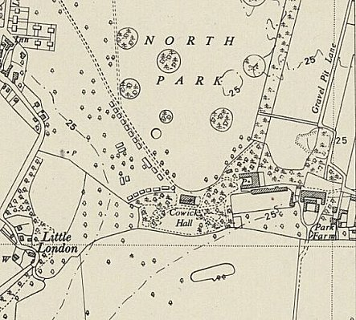
 | Ordnance Survey 1950

Oversight and development of re-education activities and English teaching for German pows was carried out by PID (Political Intelligence Department of the Foreign Office) / COGA (Control Office for Germany and Austria – UK). Visits and reports were made. The standard of the reports varied greatly. The visitors took little interest, if any, in activities other than re-education. They rarely mentioned welfare, sports, games, pastimes, crafts, etc of the pows. If there were still Italian pows in hostels, they were usually ignored by PID.

14 January 1947 – Re-education report for 691 German Working Camp. Strength; 1 officer, 496 Other Ranks, of which;

304 Main Camp at Cowick Hall
185 at Stable Road Camp, Barlow Camp 564
8 detached to Thomas Street Camp, Selby Camp 690, and Canwick, Lincolnshire Camp 1012.

Commandant; Major D W Jones, Royal Pioneer Corps Camp leader; Josef Niemann (B+)
Interpreter: Nil German M.O.: Helgo Klatt (B-)

Hostel leader; Fritz Maennig (B+). No details of what hostel this means.

The Commandant took command 2 weeks earlier.

The camp leader was considered to be doing a good job. He was dissatisfied with the pay he received as leader, but this matter was resolved by the visitor. No details were given as to why he was dissatisfied; it was often the case that admin pows received less pay than those out working at farms – possibly the case here.

Political screening: | A+ | A | B+ | B | B- | C
 | 1 | 42 | 67 | 315 | 50 | 22

47 pows were appealing against their political grades; the better the grade, the sooner repatriated, in theory. 47 pows repatriated to date.

Morale was recorded as generally good, but the major negative aspect was always slow repatriation. Most pows were politically apathetic. 15% of the camp were ‘youth’ pows (under 25); they were not considered to be a problem.

A new re-education leader had been appointed from the pows. The standard list of re-education activities was given;

Wochenpost and Ausblick – separate appendix.

Newspapers – Four daily papers and a few ‘weeklies’ bought by the camp Welfare Fund, (money mainly raised through sales in the canteen). Very few German papers received.

Library – 240 books. Requested that this be increased.

Lectures – usually every 3 weeks, popular.

Discussion groups – Newly started.

Films – Only supplied by YMCA. No commercial supplier.

Wireless – 9 sets in the camp.

Camp magazine – Issued, but suffering from lack of paper and stencils.

Press review – Held weekly with 30% of camp attending.

English instruction – 35 attending.

Information room – ready, but had received no exhibition materials.

Other camp activities –

Religion – RC priests visited from other camps. Pows able to attend local churches.

Education – separate list.

After the camp: 2020 headquarters for chemical company Croda International.

Further Information:

National Archive – 1 report used above filed under FO 1120/246.

