Camp 634 / 635 Lord Mayor's Camp, Amble, Northumberland

Prisoner of War Camps (1939 – 1948) - Project report by Roger J.C. Thomas - English Heritage 2003
OS NGR | Sheet | No. | Name & Location | County | Cond’n | Type 1945 | Comments
NU 2733 0427 | 88 | 635 | Lord Mayor's Camp, Amble | Northumberland | 4 |  | Caravan site.

Location: Just to the E of Amble  Before the camp: Field bought by a Lord Mayor of Newcastle for a poor children’s holiday camp. Military use from start of war.  Pow Camp: German pow camp.  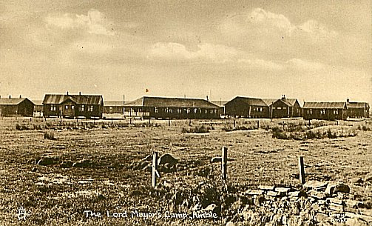  Tuck’s postcard from c1944 | 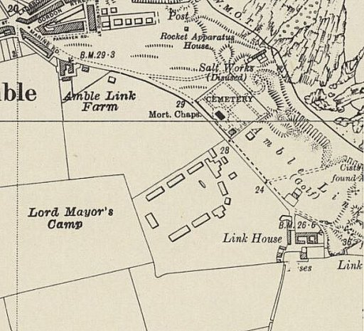
 | Ordnance Survey Revised 1938 / Published 1948

January 1945 – Camp list, the site was recorded as holding Soviets. This was for a short time before being sent on to other camps and then back to the USSR under the Yalta Agreement. Few would survive as the USSR considered surrender to be an act of treason.

“Part X – SOVIET NATIONALS.”
634 | U.S.S.R. Working Company | Lord Mayor’s Camp, Amble, Morpeth, Northumberland | N

Spring 1945 – Camp list; “German Working camp, Camp 634, Lord Mayor’s Camp, Amble, Morpeth.”

After the camp: Used for a short while to house displaced persons. 2020 open space and residential area

Further Information:

