Camp 634 (& 1008) Alvaston Camp, Alvaston, Derby, Derbyshire (aka Allerton/Allenton)

1947 Camp list
634(G.W.Coy) | N | Alvaston Camp, Meadow Lane, Derby | Derby 59454 | 27(W.O.) | V/1456/2
1008(G.W.Coy) | N | Allerton [sic] Camp, Nr.Alvaston, Derby | Derby 59214 | 27 | V/1456/2

Prisoner of War Camps (1939 – 1948) - Project report by Roger J.C. Thomas - English Heritage 2003
OS NGR | Sheet | No. | Name & Location | County | Cond’n | Type 1945 | Comments
SK 3786 3455 | 128 | 634 | Alvaston Camp, Meadow Lane, Alvaston, Derby | Derbyshire | 4 |  | Former RAF barracks associated with the nearby barrage balloon centre. See Camp no.1008.
 |  | 1008 | Allerton Camp, Alvaston, Derby | Derbyshire | 5 | German Working Company | See Camp 634

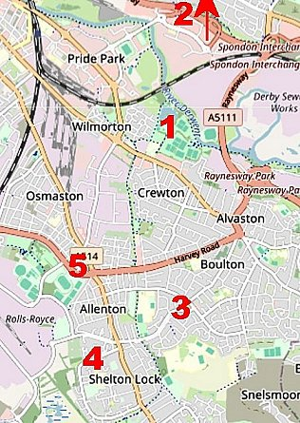 | Location: Although these are shown as linked in the English Heritage Report above, they were 2 sites. I have kept them together as published information / lists often puts Alvaston / Allenton as one site. Allenton is frequently listed as Allerton.  Several locations were recorded around Derby for 634 / 1008;  1. Alvaston Park, 2. Meadow Lane, 3. Boulton Lane, 4. Shelton Lock, 5. Allerton / Allenton.  + Smalley and Gopsall Park, likely to be hostels as they were outside of Derby.  Alvaston Park appears to have been the HQ for 634; 1948 aerial photo of many huts; Aerial Photo | Historic England  Boulton Lane appears to have been the HQ for 1008; 1948 aerial photo - Aerial Photo | Historic England  Pow Camp: Italian then German pows at 634. Reported that the Italians worked for local farmers and the Germans worked at the ordinance depot at Sinfin Lane.  1 October 1946 – Camp magazine, no.1, for Camps 1008;  Das Offene Wort : des P.o.W. Camps 1008 : Smalley - Shelton Lock - Gopsall Park - Boulton Lane - The Wiener Holocaust Library | 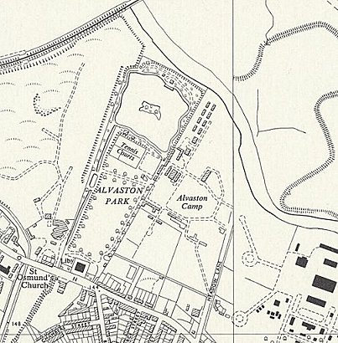
Open street maps |  | Ordnance Survey 1955

Note the 4 locations –The introduction mentions that some pows had previously been held in camps in the USA.

A report on football matches showed that 634 and 1008 were separate camps; “In the last two games, we were able to beat our strongest opponent, ‘lager 634’, with scores of 4:2 and 3:2.”

There was also a camp magazine for camp 634 magazine – Der Postilion Wochenzeitung des PW Camp 634.

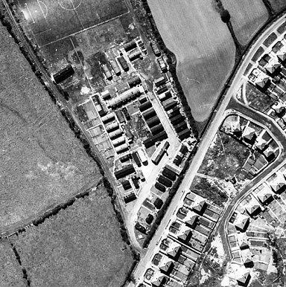 | Photo - “Prisoners of War based at Alvaston employed doing farm work off Ford Lane, Allestree, in 1945” www.derbytelegraph.co.uk – article by Jane Goddard, 18 August 2018.  Camp 634 disbanded before September 1947 according to a report made for a different camp that received its library books (Camp 266). | 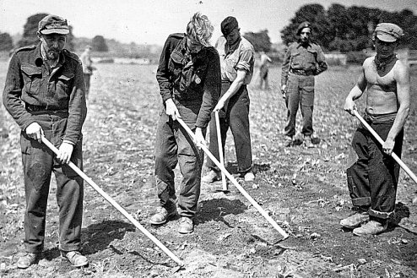

After the camp:
Further Information:
IWM have copies of the magazine for Camp 1008 dated January-April 1947. Ref E.J. 405
IWM have a copy of the Camp 634 magazine dated May 1947, Ref LBY E.J. 407

