Camp 633 Haig Lines, Crookham, Hampshire

Prisoner of War Camps (1939 – 1948) - Project report by Roger J.C. Thomas - English Heritage 2003
OS NGR | Sheet | No. | Name & Location | County | Cond’n | Type 1945 | Comments
SU 8127 5091 | 186 | 633 | Haig Lines, Crookham | Hampshire | 4 | German Working Company | Former barracks.

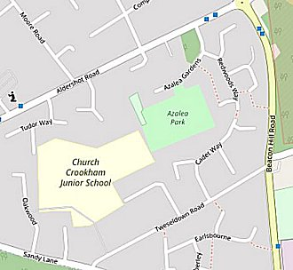  Location: The NGR above is marked on the OS map at X. This is an area with barracks originally named ‘Boyce Barracks’ and then re-named as Queen Elizabeth Barracks in 1948, (Queen Elizabeth the wife of King George VI).  However, the area called Haig Lines was located further to the NW on the map at NGR SU 818 519. I believe this was the site for the pow camp – 1. From its name, 2. From a recorded memory of the camp below.  < The area today between Tweseldown Road and Aldershot Road. © OpenStreetMap contributors  1945 aerial photo of the area - Aerial Photo | Historic England  Before the camp: Barracks built under the instruction of General Haig as an officer training camp. Reported to have Canadian troops during the war.  Pow Camp:  A memory of the camp – “I lived in Haig Lodge, Haig Lines during and after the war, from the age of 5 – 10. We had two lots of prisoners in the barracks between Tweezledown Road and Aldershot Road. We were told that the first lot were Russians. They were very friendly and used to make us carved wooden toys in exchange for cigarettes. When they left the next ones in were Italian. Again, they made a fuss of us kids. They were used to do jobs outside the camp, I know for instance that some of them decorated the windows of the army Catholic Church of Our Lady | 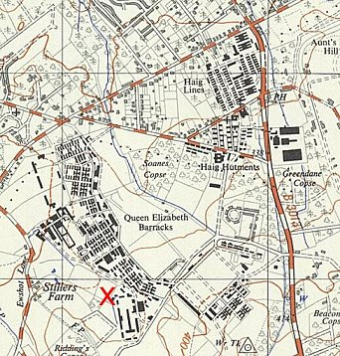
 | Ordnance Survey 1958
of Lourdes which was in Tweezledown Road. The camp was divided by the road which joined Tweezledown Road and Aldershot Road which the families used to get to the Army Post Office. The POWs used to crowd the fence lining the road just to look and chat if they got the opportunity.”
Memory by Desmond o’Connor - http://www.fleethants.com/allfleethants/expats/expats.htm (I think the nationalities of the pows may have been the other way round. If Russians were here it would be shortly after D-day and up to early 1945 when they were being repatriated. It was then recorded as a German Working company).

January 1945 – Camp list, “Part X – SOVIET NATIONALS.”

633 | U.S.S.R. Working Company | Haig Lines, Crookham, Hants | E

After the camp: Housed Hungarian and other eastern European refugees in the 1950’s. The Haig Lines were demolished in 1978. 2020 residential area, school grounds and park.
Further Information:

