Camp 633 (& 656) Boughton Camp, New Ollerton, Nottinghamshire (aka Proteus Camp)

1947 Camp List
633(G.W.Coy) | N | Proteus Camp, Ollerton, Notts | Edwinstowe 79 | 27(W.O.) | V/1456/2

Prisoner of War Camps (1939 – 1948) - Project report by Roger J.C. Thomas - English Heritage 2003
OS NGR | Sheet | No. | Name & Location | County | Cond’n | Type 1945 | Comments
SK 6835 6790 | 120 | 633 | Boughton Camp, New Ollerton | Nottinghamshire | 4 | German Working Company | Former Central Ordnance Depot. Industrial estate. See Camp no.633/656

Going for a Boughton – 3 of them:
Camp 35 - SP 749 664 – In Boughton Park by village of Boughton, Northamptonshire.
Camp 259 - SP 893 818 – Weekley camp in Boughton Park by Boughton House, Northamptonshire.
Camp 633 / 656 - SK 683 679 – New Ollerton, Nottinghamshire (aka Proteus camp).

Location: The site and depot are shown on the 1967 OS map, but not on earlier maps such as the one produced in 1955.  1947 aerial photo - Aerial Photo | Historic England  Before the camp:  Pow Camp: Mainly tented camp – 12 men to each tent. However, there were also huts at the site.  Most of the pows worked at the Royal Army Ordnance Depot a short distance from the camp.  April 1945 – Camp list recorded both 633 and 656, so likely to be 2 German Working compounds.  “633 – C.O.D. Boughton, New Ollerton, Newark, Notts.” War establishment code; V/1270/1. Same details for 656, including the telephone number and W/E.  22 June 1945 – Pow Erich Raetsch, aged 38, was killed by being crushed at a depot railway siding. He was later reinterred at Cannock Chase German Military Cemetery.  28 October 1945 - Pow Gfr Werner Spiess was accidentally shot dead. The inquest found that Private George William Christie had gone to the latrines carrying his rifle with one round. As Spiess was leaving the latrine he pushed the guard’s rifle aside, it slipped and when Christie caught hold of it, his finger touched the trigger, and the shot that killed Spiess was fired. The jury returned a verdict of accidental death. Spiess was buried at East Retford Cemetery, and later reinterred at Cannock Chase German Military Cemetery. | 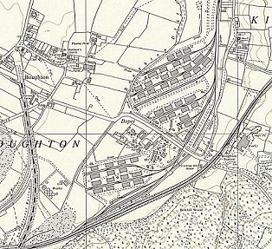
 | Ordnance Survey 1967
January 1946 – Camp Magazine no.3, with only 633 shown; Der Pfadfinder : Lagerzeitung des Arbeitslagers 633 - The Wiener Holocaust Library [The Scout, or Boy scout].

Easter 1946 - Painting below by Theo Fries titled ‘Spring in Camp 633’ – signed by the artist. It shows the administration hut, tents and fountain. © IWM EPH 10011

Known Commandants –
1945: Major Wren.

After the camp: 2020 industrial estate.

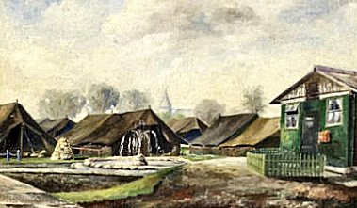
Further Information:

IWM also have a copy of the magazine dated January 1947, Ref LBY E.J. 406.

