Camp 629 Mabledon Park, Tonbridge, Kent

Prisoner of War Camps (1939 – 1948) - Project report by Roger J.C. Thomas - English Heritage 2003
OS NGR | Sheet | No. | Name & Location | County | Cond’n | Type 1945 | Comments
TQ 5948 4522 | 153 | 629 | Mabledon Park, Tonbridge | Kent | 4 |  | LARGE STANDARD. Site occupied by a school.

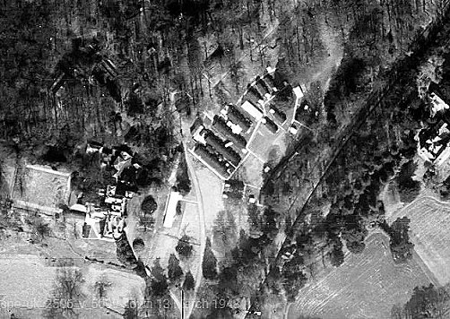  Location: The NGR above is for Somerhill Camp 40 – not Mabledon Park. The NGR for the park is TQ 579 447. The site is not occupied by a school, that was also camp 40.  1948 aerial photo - Aerial Photo | Historic England  The house is shown as Mabledon Hospital on the 1960 map. Some huts are shown, but I do not know if these are part of the camp, or being used by the hospital.  Before the camp: Country house and estate. Requisitioned at the start of the war. General Montgomery opened the site as an officers’ training centre. Officers were quartered in the house and 50 Nissen huts were erected in the fields to the south of the house for other ranks. It was then recorded as having been used by other military including Canadian Army units as a transit camp prior to D-day. | 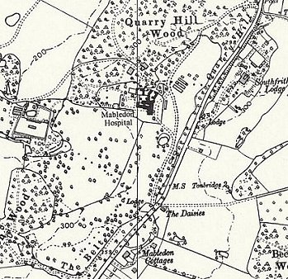
 | Ordnance Survey 1960

Pow Camp: One report stated that huts were located to the north west of the house, another stated to the south. After D-day the camp held Italian pows – possibly German pows.

Early 1945 – Camp list; “Italian Working Company, 629, Mabledon park, Tonbridge, Kent.”

Memories of Rodney Warrener, talking of his father; “During the war he sometimes did the teeth for the Prisoners of War (mostly Italian) in the Nissen Hut camp buildings, across the main road in the Mabledon Woods (now Home Farm)*. One of them made a ring for my mother out of a sixpence with an aeroplane engraved on it. I still have it. They paid for their dental work by working in our rather large garden - Mum provided sandwiches etc. There was a German prisoner of war who went to work on Nightingale Farm, the next one to Mabledon Farm - towards Southborough. His surname was Berger. I wonder if he was the one shot down. He stayed until the 1950s and knew my parents well…” * Home Farm is approximately where it says ‘The Belt’ at the S of the map TQ 5782 4421.

After the camp: Used for as short time as a rehabilitation centre for returned British pows from the Far East. Taken over by the Ministry of Health, 1955 - 1985 as a psychiatric hospital, mainly for ex-servicemen. 2020 private residence.

Further Information:

Mabledon - An Unseen Treasure; Maxwell Macfarlane, Southborough Society News, 2008/2009

Rodney Warrener extract from - ‘Mabledon & Nightingale Farms – a memory of Tonbridge’ - francisfrith.com/uk/tonbridge/mabledon-nightingale-farms_memory-86541

