Camp 626 – A/TK Range, Harlech, Merioneth

Not listed in 1945 / 1947 lists or the English Heritage Report

Location: The main accommodation buildings were located at SH 586 338.  Before the camp:  Pow Camp: Local information; “There was an Italian POW camp in Harlech on the north side of Ffordd Rhasus (leading from the A 496 to the ‘tip’ and opposite the gunnery range’s ‘village.’ The POWs worked on local farms, probably as far as Barmouth.”  Early 1945 – Camp list; “Italian Working Company, 626, A/Tk Range, Harlech, Merioneth.” [Anti Tank Gunnery range.  A pow hostel was listed at Harlech for Pabo Hall Camp 119 in late 1946, and then Glandulas Camp 101. Possibly the same place.  After the camp:  Further Information:  Archaeological report – just 1 sentence; “Towards the end of the war the camp was used to hold Italian prisoners of war, who were guarded by the Royal Pioneer Corps” Maps and aerial photos of the area for the A/Tk range.  https://walesher1974.org/her/groups/GAT/media/GAT_Reports/GATreport_1751_compressed.pdf | 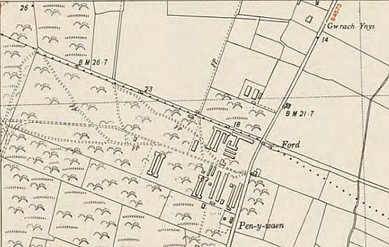
 | Ordnance Survey 1953

