Camp 619 (& 620, 642, 651, 659, 1004) Donnington Camps, Shropshire

Included in the 1945 ICRC Camp List – Labour Camp. 620 & 642. Address non communique.

1947 Camp list
651(G.W.Coy) | W | “N” Camp South Donnington, Wellington, Shropshire | Wellington 650 Ext.724 | 23(W.O.) | V/1456/2

Prisoner of War Camps (1939 – 1948) - Project report by Roger J.C. Thomas - English Heritage 2003
OS NGR | Sheet | No. | Name & Location | County | Cond’n | Type 1945 | Comments
SJ 6971 1392 | 127 | 651 | South Camp, Donnington, Wellington | Shropshire | 5 |  | Precise location not identified. NGR for centre of Central Ordnance Depot. See Camp no 651/659 & 1004.
SJ 6971 1392 | 127 | 659 | North Camp, Donnington, Wellington
 |  | 1004 | ‘E’ Camp, Donnington, Wellington

Location:  Before the camp: The very large Donnington Army Ordnance Depot was established in 1936 – though still not shown on the 1957 OS map.  Pow Camp: Individual camps, but in the same local area (within 2 miles).  Numbers associated with ‘N’ / North Camp – 619 / 620 / 642 / 651  Numbers associated with ‘E’ / South Camp – 651 / 659 / 1004  Camp names seemed to be used quite ‘freely’ – also seen in reports; ‘The Humbers’ and ‘L’ Camp, all referring to the same Donnington site.  Described by Shropshire Council HER (PRB): 29139;  “Cluster of 3 Second World War prisoner of war camps around the military base at Donnington, known as South (651), North (659) and East (1004). It is reputed that they dug an escape tunnel but it was never used. They were in use up until 1948.”  1945 – camp 620 recorded with Italian pows.  Early 1945 – Camp list with 3 sites;  “Italian Working Company, 619, ‘N’ Camp North, Donnington, Wellington, Salop.”  “Italian Working Company, 620, ‘N’ Camp North, Donnington, Wellington, Salop.”  “Italian Working Company, 642, ‘N’ Camp North, Donnington, Wellington, Salop.” | 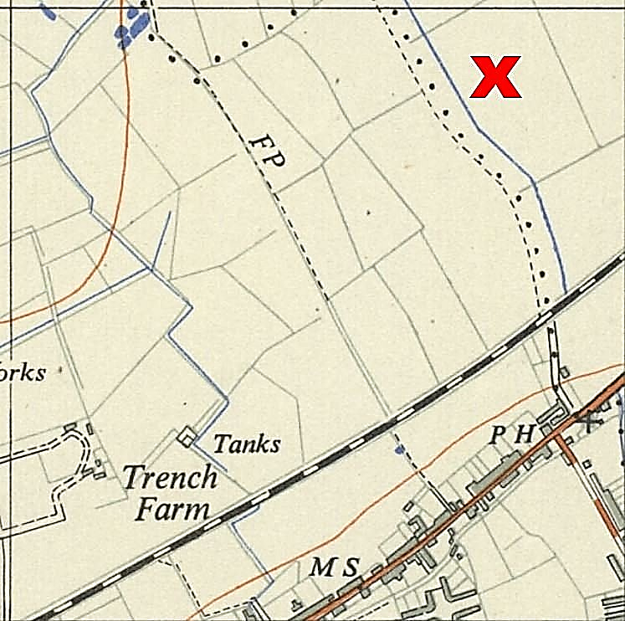
 | Ordnance Survey 1957
April 1945 – Camp list; “German Working Company, 659, Humbers, Donnington, Wellington, Salop.” War establishment V/1270/1. ‘The Humbers’ is an area just to the NE of the X on the map.

7 May 1945 – Progress report No.80 by the Segregation Section of COGA; “WORKING COMPANY no. 659 – D.P.W. have now decided that this Working Company which is to be formed on the 16th May at Donnington will contain all ‘blacks.’ The population will be 425 Ps/W and these will be drawn by D.P.W. from base Camps.”

‘Blacks’ = Political grade C, Nazis.
Oversight and development of re-education activities and English teaching for German pows was carried out by PID (Political Intelligence Department of the Foreign Office) / COGA (Control Office for Germany and Austria – UK). Visits and reports were made. The standard of the reports varied greatly. The visitors took little interest, if any, in activities other than re-education. They rarely mentioned welfare, sports, games, pastimes, crafts, etc of the pows.

13/14 November 1945 - English education report on; “Visit to COD Camp & ‘S’ Camp, 651-659.” Strength of both camps; 1932.

“Although these 2 camps have their respective commandants, they are in one compound, a small football field being the dividing line.

The British, and all Ps/W are under canvas. A few huts in and outside the compound are used as cookhouses. A further hut was erected for recreation purposes; this hut can, when tables are removed hold 200 seated men.”

Camp 659 – Half the size of 651. Unsuitable accommodation for teaching; 15 beginners / 8 Intermediates. Lessons were given in the kitchen.

No description of Camp 651 was given.

Other weekly classes for; Electrical engineering, maths, economics, agriculture and tailoring.

Late 1945 ? – An undated Petition was sent to the War Office by a group of pows at Camp 651. They had been based on the Channel Islands and believed they had been promised early repatriation. They asked for the W.O. to look into their position with regard to early release. The same request was made by other pows who had been on the Channel Islands in other camps. Early repatriation was not granted.

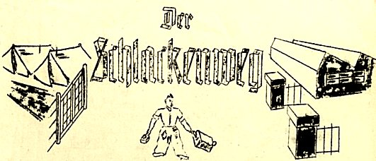
1946 – Intake of many pows from camps in the USA. Most of the ex-US pows had a very low morale as they had been misinformed in the US they were being repatriated. Instead, they found themselves in working camps in the UK. It is likely that the nature of Camp 659 changed at this point from being mainly ‘Black’ (C), to a more mixed political grade. This was shown in the December 1946 report below.
April 1946 – Camp magazine; No.1 for 651 German Working Company; Der Schlakenweg : Lagerzeitung der PoW-Coys 651/659 Donnington - The Wiener Holocaust Library.

Mentions a theatre group, religious services, sports and chess.

Commandant – Major H Boynton.

Banner picture showed tents in use + large storage huts in the depot.

Easter 1946 – Camp magazine; No.2, now for two camps, 651 and 659; Der Schlakenweg : Lagerzeitung der PoW-Coys 651/659 Donnington - The Wiener Holocaust Library

From Summer 1946 - all reports are headed ‘Camp 659,’ this seems to have become the main ‘camp.’ The other sites were still mentioned in the reports, but with no reference to any separate Commandant.

19 July 1946 – English Inspector’s Report. Camp 659; ‘E’ Camp. The report also covered Camp 651, total strength; 1269.

Commandant; Major T V Riley.

50 pupils in 2 classes at 659. 92 pupils at 651.

14 October 1946 – English Inspector’s Report. Camp 659; “‘E’ Camp, South.”

Strength; E Camp 576. 12 beginners, 8 Internediate.
L Camp 524. 15 beginners.

Pows recorded as being accommodated in huts. Pows often working very long hours for the harvest.

4/6, 9 December 1946 – Report on Camp 659; to; “Organise re-education, Investigate suitability of camp leader, Screen potential ‘whites’ and Group 12.” Whites = political Grade A, non-Nazis. Group numbers were given to batches of pows for repatriation.

Strength; 1 officer (the M.O.), 1041 Other Ranks. Of which;

474 at HQ (‘E’ Camp)
480 at ‘L’ Camp (1 mile)
87 at ‘S’ Camp (1 mile)
1 in a billet.
22 attached from 1018 Company. [Acksea camp 34/1018].

Commandant: Major G A G Muggleton Camp leader: Ob Bootsmaat Otto Reckstat (A)
Interpreter: Sgt M Engel Deputy C/L: St.Fw K Truschkowski (B)
German M.O.: St/Arzt O Krauser (B)
‘L’ Camp leader:Hengsch Gustav (B) [or Bengsch]

The Commandant had been in post for 3 weeks. He was generally supportive of re-education.

The Interpreter was young and “rather inexperienced,” but conscientious, hard-working and supported re-education.

Camp leader Reckstat had been reported in November for; “Prussian barrack square manners” and not supporting re-education. He had also contributed an article for the camp magazine which was regarded as cynical and “destructive criticism.” Despite the fact that he was regarded as an anti-Nazi (A grade), he was regarded as unsuitable as Camp leader and was being transferred to Sudbury, Camp 23.

It was recommended that the deputy should become the new camp leader.

Political screening: | A+ | A | A- | B+ | B | B- | C | C+ | Unscreened
 | 1 | 39 | 1 | 89 | 420 | 35 | 80 | 8 | 369

Morale was regarded as ‘fair.’ There was a general fear of Russian intentions for Germany. Mail was received regularly, except from the Polish occupied zone. Many pows referred to the excellent treatment they received from the British staff.

321 pows were ‘youth’ (under 25). They were seen as being indifferent to re-education activities.

The standard list of re-education activities was given;

Wochenpost and Ausblick – separate appendix.

Newspapers – Satisfactory range of British papers. A few Swiss papers were sent from COGA. German papers were only received if sent by relatives.

Library – “Quite well stocked.”

Lectures – 1 lecture recorded; pows from all sites attended at the main camp. More requested.

Discussion groups – None.

Films – Fortnightly films supplied by COGA (usually documentaries). Gaumont British films also shown, but the rise in cost from 2d to 6d caused many complaints.

Wireless – 1 set in the dining hall, 1 for the living quarters, and 1 at ‘L’ camp. Some pows had purchased their own sets when in the USA.

Camp magazine – Ceased, but hoped to start up again.

Press review – A precis was issued of English and German broadcasts.

English Instruction – separate appendix.

Information room – None.

Other camp activities –

Religion – RC 40%, Protestant 60%. RC Padre, Haeuser, visited for 1 day per week. Protestants attended services at the local methodist church and some services were held in camp.

Education – Classes for French (15 pows).

Entertainment – A theatre group. An orchestra of 12 members playing classical and dance music.

December 1946 – football matches recorded in the camp magazine between Worfield (Satellite camp for Coven Camp 151) and Donnington Camps 651 and 659.

29 – 31 January 1947 – Report on Camp 659. To; “Organise re-education.” Strength; 1 officer, 936 OR. Of which;

436 at HQ (‘E’ Camp)
414 at ‘L’ Camp (1 mile)
87 at ‘S’ Camp (1 mile)
1 in a billet.
22 attached from 1018 Company.

Commandant: Major G A G Muggleton Camp leader: St.Fw K Truschkowski (B)
Interpreter: Sgt M Engel Deputy C/L: Dustav Bengsch (B) ‘L’ Camp. [or Hengsch]
German M.O.: St/Arzt O Krauser (B)

Political screening: | A+ | A | A- | B+ | B | B- | C | C+ | Unscreened
 | 13 |  |  | 76 | 529 | 71 | 83 | 6 | 159

150 pows were appealing against their political grade; the better the grade, the sooner repatriated, in theory. 126 pows repatriated to date.

Morale was recorded as ‘fairly good.’ Positive factors were; removal of unsuitable camp leader, re-education activities, the start of repatriation.

Youth pows were not regarded as a problem and many were taking part in activities.

Changes noted for activities:

Newspapers – It was difficult to obtain Swiss or German papers.

Library - 888 books.

Discussion group – started, with 100 to 200 pows attending weekly.

Films – supplied by YMCA and Gaumont British. There were complaints that the GB films were often very old.

Camp magazine – restarted with 120 copies.

Religion – Services in Donnington and Wellington could be attended.

Entertainments – Football and handball very popular. Football matches played against teams from other camps and British military teams. The theatre group and orchestra continued.

16 February 1947 – English Inspector’s Report. Strength 422; for just Camp 659.

“Camp 659 also controls Camp L (421 P/W, whose English pupils attend the classes in Camp E) and Camp S (10 bakers and 79 drivers).”

42 pupils studying English at 651.

1947 - “Hermann Ganter was a prisoner at Donnington and fell for an ATS sergeant, Monica Cann, who was teaching English in the camp. They married in February 1947 at the Registry Office in Wellington and honeymooned at the Charlton Hotel. She was the first Englishwoman to marry a German PoW and, since it was against the law to fraternise with the enemy at this time, they were both taken to court and fined. The Army split them up but the marriage was still legal. Public opinion was so strongly in the couple's favour that the law was changed in the summer of 1947.”

Further information on the marriage. The couple met at camp ‘E’ (the Central Ordnance Depot site). They married in January 1947; Monica was 22 and Hermann was 28. Ganter was wearing borrowed clothes, (one article says a uniform, another a civilian suit). The witnesses were a lady from a nearby house and a man found in a library. Apparently, the couple had a brief honeymoon in The Charlton Arms Hotel, Ludlow – why his absence from the camp was not noticed, is not explained. When Hermann returned to the camp the marriage was not revealed to the authorities there. They met up when possible in the evenings.

The marriage was first revealed to the public on 17 May 1947 by the Derby Daily Telegraph (‘POWs Marriage Question’); the Nottingham Evening Post (‘A.T.S. – P.O.W. Wedding’); and the Yorkshire Post, (‘P.O.W.’s Secret Marriage’). Initial reactions were very mixed.

Cann was subsequently charged in May at Wellington Police Court that on 9 January she signed a false declaration of marriage, and on 11 January she caused the insertion of a false statement into the marriage registry. She was remanded on bail for 1 week. The charges were revealed in the press on 28 May 1947 by the Derby Daily Telegraph (‘A.T.S. Who Wed P.O.W. Charged’); the Nottingham Evening Post (‘A.T.S. Who Wed German’); the Lancashire Evening Post (‘A.T.S. Who Wed P.O.W. Remanded’); and on the following day by the Dundee Courier (‘A.T.S. Bride Accused’).

The press reports aroused a good deal of public debate on the issue of fraternisation and the prohibition of marriage to German pows. The question was raised with the Secretary of State for War, Frederick Bellenger, about the government’s attitude towards the marriage ban. Bellenger was reluctant to answer:

Mr. Bellenger - I believe that the matter is sub judice at the present moment, and therefore it would be improper for me now to give a reply.
Mr. Driberg -- With respect, is it not only a particular point that is sub judice, that is to say, the alleged false entries in the register? What is my right hon. Friend's attitude to the general question of the marriage?
​Mr. Bellenger - As to that particular marriage I cannot say any more than I have said in answer to the general question, namely, that the whole principle is under consideration.
Mr. Hector Hughes - Arising out of the original reply, is it not unreasonable to allow this social intercourse and rule out the probable consequences of it? Would it not be reasonable to allow both?
Mr. Bellenger - I do not know that I would agree that all those associations end in wedlock.
Mr. Stokes - Is not my right hon. Friend the last person in the world to obstruct the course of nature in this matter? Does he not realise that he cannot resist the inevitable course of nature?
Mr. Bellenger - I have never attempted to resist the inevitable course of nature.
Mr. Ronald Chamberlain - If there are difficulties about British women marrying German prisoners in this country, will he try to make facilities for British women to go out to Germany to marry returned prisoners of war? I have the case of a constituent who wishes to do this now. May I have an answer?
Mr. Bellenger - I think that is an entirely different point from the one raised in the Question.
(House of Commons, 3 June 1947, Vol 438 cols 16-7)

Monica Cann pleaded guilty to both charges on 4 June 1947 and received a minor fine of £2 for each charge and court costs. However, the marriage itself was not declared illegal. She stated: 'I married him because I loved him, and I do not regret it one bit. I knew it would be hopeless to try to get married through the proper channels. I did not put Ganter's true name because if I had they might have guessed he was a German'.

Hermann Ganter was transferred to Sudbury Camp. By this time a good deal of public sympathy was being expressed for this couple and for others. Hermann was repatriated on 22 July 1947 with Monica Cann telling the Derby Daily Telegraph that she planned to follow her husband to Germany. It is believed Hermann became a mechanic, (the profession listed for him on the marriage certificate) and that eventually Monica did join him. Sad to say, the marriage did not last, and Monica returned to Britain.

12 June 1947 - German pow from Camp 1004, Albin Gross, hanged himself in the woods near Wrockwardine. He was buried at Stafford Cemetery.

Known Commandants;
1946 – 651 Major H Boynton
1946 - 659 Major T V Riley.
1946 – 659 Major G A G Muggleton

After the camp: Military base / depot

Further Information:

National Archives – FO 939/187 – 659 Working Camp, “E” Camp, Donnington, Shropshire. Dated 1945-1947. Used above.

Details about the marriage came from several sources – in particular:

- British attitudes towards German prisoners of war and their treatment: 1939-48 by Alan Patrick Malpass, available from Sheffield Hallam University Research Archive.

- Wrekin News, July 2016

