Camp 618 Inveraray, Argyllshire (aka Town Camp)

Location: A suggested NGR of NN 089 098, ‘Malt Land’ about 1.5km NNW of Inverary.  Before the camp:  Pow Camp:  Early 1945 – Camp list; “Italian Working Company, 618, Sc, Town Camp, Inverary, Argyllshire.”  After the camp:  Further Information: | 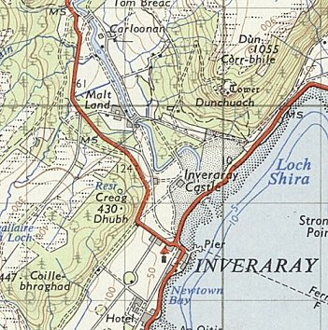
 | Ordnance Survey 1956

