Camp 615 Holmesdale, Nutfield, Nr Redhill, Surrey

Included in the 1945 ICRC Camp List – Labour Camp. 615. Address non communiqué.

Location: Holmesdale is located at NGR TQ 309 503.  The book, ‘Nutfield Memories of World War II’ (Nutfield History Group, 2012) also records Italian pows, (possibly Germans) at High Beech which is just 0.75km south of Holmesdale (TQ 312 497).  Before the camp: Country house and estate. Requisitioned for military use in WW2.  Pow Camp: Italian labour camp. | 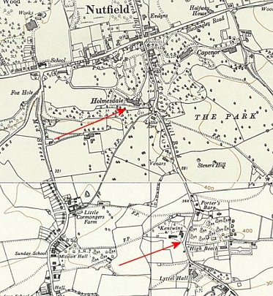
  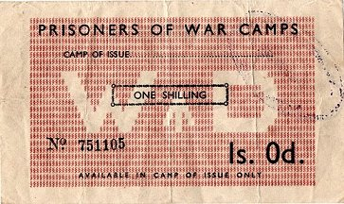 | 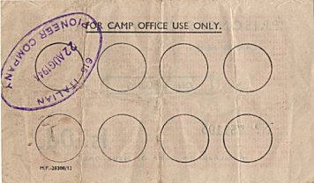
  1944 Camp token money – ‘615 Italian Pioneer Company’
 | Ordnance Survey 1961
Early 1945 – Camp list; “Italian Working Company, 615, “Holmesdale”, Nutfield, Nr Redhill, Surrey.”

This is likely to be the same ‘Nutfield’ site that became a hostel for Brookhouse Camp 238, then Merrow Downs Camp 57

After the camp:

Further Information:

