Camp 614 Stoneham Camp, Eastleigh, Hampshire (aka Chestnut Avenue)

1947 Camp List
614(G.W.Coy) | S | Stoneham Camp, Eastleigh, Hants | Chandlers Ford 2561 | 30(W.O.) | V/1270/3

Prisoner of War Camps (1939 – 1948) - Project report by Roger J.C. Thomas - English Heritage 2003
OS NGR | Sheet | No. | Name & Location | County | Cond’n | Type 1945 | Comments
SU 4570 1729 | 185 | 614 | Stoneham Camp, Eastleigh | Hampshire | 5 |  | Precise location not identified, NGR given for camp to the north eastern end of Eastleigh airport.

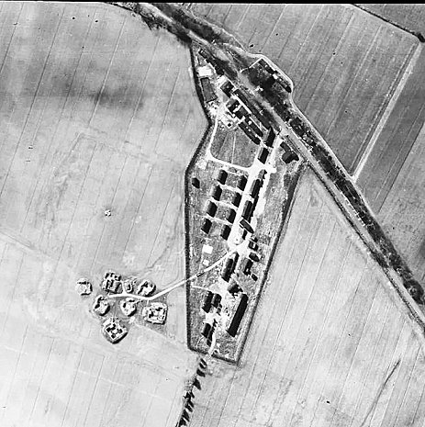  Location: SU434 185; Chestnut Avenue on the edge of Eastleigh. (Shown as Displaced Persons Camp in 1963).  1948 aerial photo - Aerial Photo | Historic England  Before the camp: May 1942 the military took command of the area including Chestnut Avenue  Pow Camp: German pows.  2 January 1945 – Postcard shown below to Germany. From, ‘The London 1945 United Nations Slogan Cancellation’ by Clayton Wallace.  April 1945 – Camp list; “German Working Company; 614, Stoneham, Nr.Eastleigh.”  16 August 1945 – International Red Cross (IRC) visit by M Chavan (translated from original French).  Capacity 450 – actual 428, including 49 staff.  Commandant: Major R Leslie  Camp Leader: Zugwachtmeister Peter Hinsen | 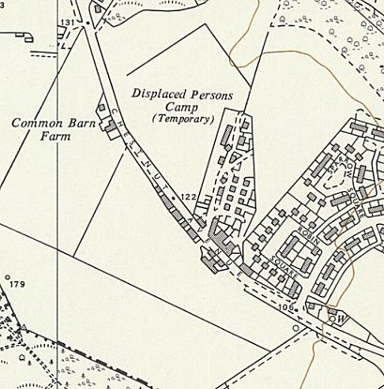
 | Ordnance Survey 1963
Located beside a road, in the open countryside, in a perfectly healthy region. It was used by British troops; for the past 6 months, prisoners have been quartered there.

328 men were housed in barracks and 100 in tents (the youngest). Each prisoner received a straw mattress, a sleeping bag and a blanket.

Sanitary facilities – The latrines are adequate (flush system). Prisoners have access to hot and cold showers. The facilities in this camp are particularly well-maintained.

Food – Complies with the ‘War Office’ rationing plan of May 28, 1945. No complaints are noted on this point.

Medical Care – Camp Doctor: Dr. Walter Kurz, A875147. The infirmary is very well equipped with good supplies. The overall illness rate is 1%. No deficiency, contagious, or epidemic diseases have been reported. There have been no deaths.

Dentist – None at the camp. The prisoners regularly go to a nearby pow camp, where they receive treatment from a pow dentist.

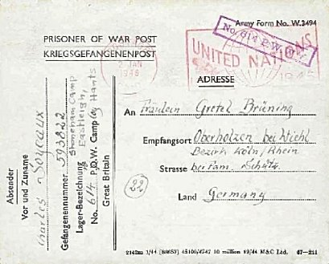
Clothing – A few shirts are missing; more should arrive very soon. The rest is in order.

Work and pay – Type of work: demolition and construction of barracks. Wage: ¾d and 1½d per hour, 48 hours per week.

Canteen – This is well set up.

Religious Services – A British Catholic chaplain visits; one of the pows is a Protestant chaplain.

Recreation – The camp has a sports field. The library has 100 books. English lessons are offered. Music, films, and radio are available.

Correspondence – The prisoners have been kept informed of the International Committee of the Red Cross efforts to address this situation.

General remarks - This camp is very well organized and very clean. Excellent cooperation has been established between the commanding officers and the prisoners. It makes a very good impression.

Each POW in this camp has sent a capture card. [Postcard notifying relatives of being held as a pow].

September 1945 - Appendix to HQ Southern Command War Diary; 614 Stoneham camp, Eastleigh – German working company – capacity 450.

15 February 1946 – Camp magazine, No.5; Die Frieie Meinung : Lagerzeitung der 614 P.W.W. COY. - The Wiener Holocaust Library
3 May 1946 – International Red Cross (IRC) visit by Dr E H Strehler. (Edited).

Capacity 500 – actual; 1 officer, [the M.O.] 450 Other Ranks.

Commandant: Major R Leslie

Camp Leader: Zugwachtmeister Peter Hinsen

Description of the camp – 2 new living barracks have been erected, no other changes since the last visit. 4 blankets per man.

Sanitary installations – Satisfactory

Food – Satisfactory. No shortage of bread ration.

Infirmary – 5 patients with stomach problems were repatriated on the day of the visit. They were kept in this camp until they were repatriated instead of being sent to a transit camp.

M.O. Dr Kurtz.

State of health of pows – Very good.

Clothing – Supplies often slow.

Laundry – Satisfactory.

Pay – Unskilled workers 3/- (3 shillings). Skilled workers and supervisors 8/-

Work – Construction of barracks for military purposes 8 hours a day. Transport is in open and covered lorries.

Canteen – Very well stocked, 15-20 cigarettes per week.

Religious activity – A protestant chaplain is in the camp. The catholic padre comes from Camp C27 from time to time. C27 is about 400 yards away.

Free time – Orchestra with self-made instruments. Classes for languages, lectures, etc. The camp has its own newspaper. Choir, sports, etc. All activities are well organised.

Mail – 110 men have not received news from home. Correspondence with the US Zone and Poland is very bad.

Complaints – none.

Discipline – Good

General impression – Very good camp owing to the cooperation with the Camp Commandant. The morale of pows in the camp in the words of the camp leader is;

Morale is falling. All the POWs are thinking of home. Interest has waned in every aspect, both in the work itself and in developing camp life. The uncertainty of repatriation and worries over families back home are causing the most stress. The mail system is working at last.

March 1947 – Notice sent to local council that Stoneham Camp would be available for use as temporary housing from 31 March 1947.
Known Commandants;

1945 Major R Leslie.

After the camp:

Further Information:

Original documents including the IRC reports used above are found in -
https://www.eastleighhistory.org.uk/sites/default/files/document/OP59%20-%20Four%20Military%20Camps%20in%20Eastleigh%20(compressed).pdf

