Camp 613 Old Dalby Camp, Old Dalby Lane, Melton Mowbray, Leicestershire

1947 Camp List
613(G.W.Coy) | N | North Camp, Old Dalby, Nr.Leicester | Melton Mowbray 520 Ext.213 | 25(W.O.) | V/1456/2

Prisoner of War Camps (1939 – 1948) - Project report by Roger J.C. Thomas - English Heritage 2003
OS NGR | Sheet | No. | Name & Location | County | Cond’n | Type 1945 | Comments
SK 6879 2465 | 129 | 613 | Old Dalby Camp, Old Dalby Lane, Melton Mowbray | Leicestershire | 4 |  | Large complex of accomodation hutting associated with RAF Depot. NGR given to feature centre.

Location: About 9km NW of Melton Mowbray. One reference stated that the camp was where the Queensway residential area is now, that would place it to the East side of the camp near to where the map says Hatton Lodge..  1947 aerial photo showing many huts in the area - Aerial Photo | Historic England  Before the camp: Ordnance / storage depot and workshops with accommodation for civilian workers and military, mainly in Nissen huts – the smaller buildings shown to the N of Old Dalby Road.  Pow Camp: The pow camp was believed to have held about 300 pows, though the War Establishment number gave a capacity for about 1000. Local history states it opened in 1943 and held Italian then German pows.  March 1948 – listed as a hostel for Langar Camp 262.  After the camp: The depot closed in 1996. Old Dalby Business Park.  Further Information:  Christmas 1946 - Camp Magazine No.4, Note location; “North Camp Old Dalby.” Rundschau : Herausgeber Prisoner of War Working Coy. 613 : North Camp Old Dalby - The Wiener Holocaust Library  Camp leader; Albin Wehr.  February? 1947 - Camp Magazine No.5; Rundschau : Herausgeber Prisoner of War Working Coy. 613 : North Camp Old Dalby - The Wiener Holocaust Library  Commandant; Major H J Head Camp leader; Albin Wehr. | 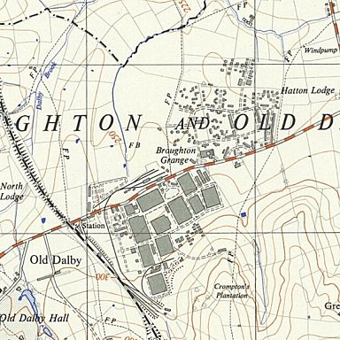
 | Ordnance Survey 1957
Undated, but referred to an event on 1 February. Events listed Barkby hostel. Football matches were played against other camps.

22 August 1947 – death of pow Helmut Engel. Buried at Loughborough (Leicester Road) Cemetery. Believed to have been held at Old Dalby Camp – location not confirmed.
Hostel

Barkby

Previously independent Camp 590/616.

