Camp 612 Honduras Camp, Kirkpatrick Fleming, Dumfriesshire (aka Mossknowe)

Prisoner of War Camps (1939 – 1948) - Project report by Roger J.C. Thomas - English Heritage 2003
OS NGR | Sheet | No. | Name & Location | County | Cond’n | Type 1945 | Comments
 |  | 612 | Honduras Camp, Kirkpatrick Fleming | Dumfrieshire |  |  | Scotland

Location: Just S of Kirkpatrick Fleming. NGR NY 278 698. Camp shown on the 1947 map.  Before the camp: Farmland at side of country house.  The name of the camp arises from the British Honduras Forestry Unit who were brought to Scotland in September 1941 to replace forestry workers who were away at war. Most of the Hondurans returned home in autumn 1943 when the unit was disbanded. Some did not survive and four are buried in the churchyard at Kirkpatrick Fleming.  There were accommodation huts, dining rooms, kitchens, ablutions, drying rooms, latrines and a large recreation room / canteen. There was no electric lighting, in some reports heating was reported as inadequate, and the ablutions / latrines in poor condition.  Pow Camp: Italian pows then a German Working Camp.  Canmore details; “At least 29 huts of varying sizes, most with pitched roofs. Entrance to the camp was from the W on the B6357 road, opposite Beltenmont Mill.” Huts were wooden construction for up to 12 men. | 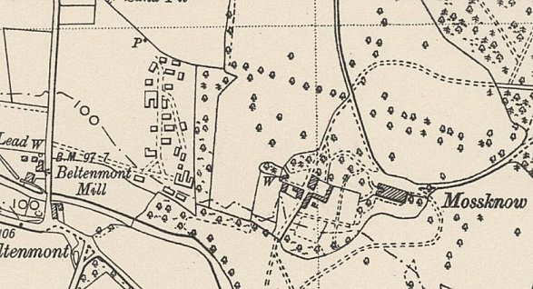
 | Ordnance Survey 1947
Spring 1945 – Camp list – “Italian Working Company 612, Honduras camp.” One memory; “Ruby Hardisty mentioned Italian POW’s who were camped at Kirkpatrick Fleming and would often cycle to Gretna to use the local amenities such as the cinema, “they were always at the pictures, that’s where most of them learnt English, the pictures mostly.”
June 1946 – listed as a pow hostel for Hallmuir Camp 68
After the camp: Lower part of site part built on.
Further Information:
http://canmore.org.uk/site/273036

Air photographs - 106G/Scot/UK 40, 3065-3076, flown 4 May 1946

