Camp 612 Canonbie Camp, Canonbie, Dumfriesshire (aka Brighton Camp)

Included in the 1945 ICRC Camp List – Labour Camp. 612. Canonbie Camp, Dumfriesshire.

Location: Canonbie is about 3 km N of the England-Scotland border. Local history places the camp in area NY 405 768 (X on map) – just under ‘Brighton Plantation.’  Before the camp:  Pow Camp: Italian labour camp.  After the camp: The camp housed Australian woodmen post war.  Further Information:  Possibly linked with Camp 612 at Kirkpatrick Flemming about 9 miles away. | 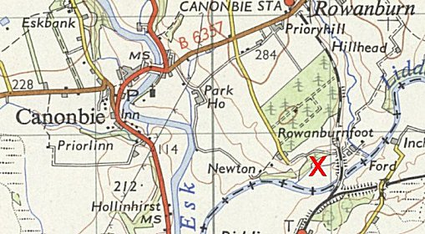
 | Ordnance Survey 1955

