Camp 590 (& 616) Barkby Camp, Barkby Lane, Leicester, Leicestershire

Included in the 1945 ICRC camp list – Labour Camp. 590. Barkby Camp, Barkby, Syston, Leics. 616 is listed as ‘non communiqué’.

Prisoner of War Camps (1939 – 1948) - Project report by Roger J.C. Thomas - English Heritage 2003
OS NGR | Sheet | No. | Name & Location | County | Cond’n | Type 1945 | Comments
SK 6274 1021 | 129 | 616 | Barkby Camp, Barkby Lane, Leicester | Leicestershire | 4 |  | Former Heavy Anti-aircraft battery (HAA Bty)

Location: NGR below Off Barkby Lane, the housing next to the marked area is pre-war. About 7km NE of Leicester. Location with thanks to Martin J Richards systonimages.co.uk  Before the camp: farmland  Pow Camp: Opened 1942 for Italian pows.  Early 1945 – Camp list; “Italian Working Company, 616, Barkby Road, Leicester.”  Early 1947 – Listed as a hostel for Old Dalby Camp 613.  After the camp: Requests for conservation of site made June 2011 during appraisal of area. Now farmland. | 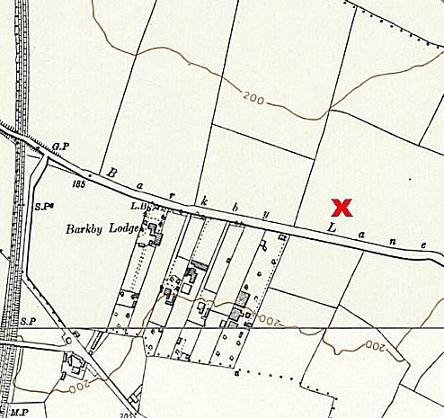
 | Ordnance Survey 1958

